Objective:
- To build an internal portal for managing software license inventory, assignments, requests, and reports replacing inefficient manual tracking.

Project Scope:
- User Authentication & Role Access
- Software & License Inventory Management
- License Request and Approval Workflow
- License Assignment Tracking
- Expiry Alerts & Notifications
- Reporting (usage, history, expiries)
Project Timeline:

Phase | Description | Week 1 | Week 2 | Week 3 | Week 4 | Week 5 | Week 6
1. Planning & Design | ERD, flowcharts, wireframes | ■■■■■■
2. Setup & Auth | Laravel + React setup, Breeze, roles | ■■■■■■ | ■■■■■■
3. Inventory Modules | Software & Licenses CRUD, ESD vs Subscription |  | ■■■■■■ | ■■■■■■
4. Request Workflow | License requests, approval logic |  |  | ■■■■ | ■■■■■■
5. Assignment Logs | Assign licenses, track usage, log activity |  |  |  | ■■■■■■
6. Notification System | Email + dashboard alerts |  |  |  |  | ■■■■■■
7. Reports Module | Usage reports, filters, Excel export |  |  |  |  | ■■■■■■
8. Testing & QA | Functional + UAT testing |  |  |  |  |  | ■■■■
9. Deployment | Production deploy, cron jobs, backups |  |  |  |  |  | ■■■
Buffer / Debug | Feedback changes, bug fixes |  |  |  |  |  | ■■■■

Admin Features:
Dashboard

- Overview (Licenses summary,request, expiring soon)
- Quick actions (assign, request, import)
- Notification cards

Software Products

- Add new product
- Product List
- Brand List
- Category List
- Vendor List
- Type Management (ESD, Subscription, Perpetual)

Licenses

- License List (with status available, assigned, expired)
- Import licenses (excel)
- Export licenses
- Expiry Tracker
- License Assignment History

License Request

- Request List (Pending / Approved / Rejected)
- Request Details /Approval
- Submit Request (for staff only)

User Management

- User List
- Role(Automatic) & Permission Management
- User Logs
- Custom Permission

Notifications

- System Alerts (license expiry, low stocks)
- User Notifications (assignment updates, request status)

Reports

- License Usage Report
- License Assignemnt Report
- Expiry Report
- Request Summary Report
- Audit & Activity Logs Report

Staff Features:
Dashboard

- Recent Activity

License Request

- Submit a new license request
- Select product, enter quantity, provide branch & email
- Request are routed to admin for approval
- View request status
- Automatically receive license via email upon approval

Assigned Licenses

Notifications

- Receive alerts, license request status change, license assigned and license expiring soon

Reports

DATABASE

users
CREATE TABLE users (
id BIGINT AUTO_INCREMENT PRIMARY KEY,
name VARCHAR(255),
email VARCHAR(255) UNIQUE,
password VARCHAR(255),
role ENUM('admin', 'staff') DEFAULT 'staff',
branch VARCHAR(255), -- optional
created_at TIMESTAMP,
updated_at TIMESTAMP
);

software_products
CREATE TABLE software_products (
id BIGINT AUTO_INCREMENT PRIMARY KEY,
name VARCHAR(255),
type ENUM('ESD', 'subscription', 'perpetual'),
brand VARCHAR(100),
category VARCHAR(100),
vendor VARCHAR(100),
created_by BIGINT,
created_at TIMESTAMP,
updated_at TIMESTAMP,
FOREIGN KEY (created_by) REFERENCES users(id)
);

licenses
CREATE TABLE licenses (
id BIGINT AUTO_INCREMENT PRIMARY KEY,
software_product_id BIGINT,
license_key TEXT,
status ENUM('available', 'assigned', 'expired') DEFAULT 'available',
expiry_date DATE,
assigned_to BIGINT, -- user/customer id (nullable)
assigned_at TIMESTAMP NULL,
FOREIGN KEY (software_product_id) REFERENCES software_products(id),
created_at TIMESTAMP,
updated_at TIMESTAMP
);

license_requests
CREATE TABLE license_requests (
id BIGINT AUTO_INCREMENT PRIMARY KEY,
product_id BIGINT,
quantity INT,
branch VARCHAR(255),
email VARCHAR(255),
status ENUM('pending', 'approved', 'rejected') DEFAULT 'pending',
requested_by BIGINT,
approved_by BIGINT NULL,
requested_at TIMESTAMP,
approved_at TIMESTAMP NULL,
FOREIGN KEY (product_id) REFERENCES software_products(id),
FOREIGN KEY (requested_by) REFERENCES users(id),
FOREIGN KEY (approved_by) REFERENCES users(id)
);

notifications
CREATE TABLE notifications (
id BIGINT AUTO_INCREMENT PRIMARY KEY,
user_id BIGINT,
message TEXT,
read_at TIMESTAMP NULL,
created_at TIMESTAMP,
FOREIGN KEY (user_id) REFERENCES users(id)
);

license_assignment_logs
CREATE TABLE license_assignment_logs (
id BIGINT AUTO_INCREMENT PRIMARY KEY,
license_id BIGINT,
assigned_to BIGINT,
assigned_by BIGINT,
assigned_at TIMESTAMP,
FOREIGN KEY (license_id) REFERENCES licenses(id),
FOREIGN KEY (assigned_to) REFERENCES users(id),
FOREIGN KEY (assigned_by) REFERENCES users(id)
);

WORKFLOW PER MODULE

Authentication Flow

- Laravel handles session or token-based login.
- Staff/Admin logs in.
- Admin has full access.
- Staff can only ( Submit license requests, View their assigned licenses).

License Upload / Inventory

- Admin selects a software product or adds a new one
- Admin uploads/imports license keys in bulk (CSV, Excel).
- Each key is stored as available.

License Request Flow

- Staff submits a request (product, qty, email, branch).
- Laravel stores request in license_requests.
- Admin sees request on dashboard.
- Admin approves request: ( System assigns licenses, Marks them as assigned, Sends email or portal message with keys.)
- If stock is low, alert is triggered.

License Assignment Workflow

- Admin manually assigns or system auto-assigns during approval.
- Records are updated: ( licenses.status = assigned , assigned_to = user_id or email)
- Logged in license_assignment_logs.

Expiry Notification

- Daily schedule (Laravel schedule:run) checks for:
- Licenses expiring in X days.
- Unused licenses.
- Triggers: ( Email alerts, Dashboard notifications )

Diagram
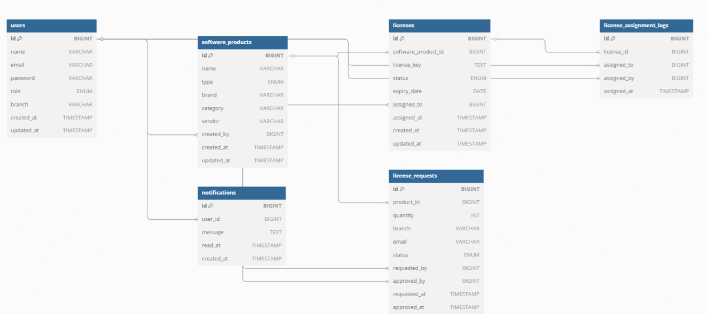

Flowchart
Login & Authentication
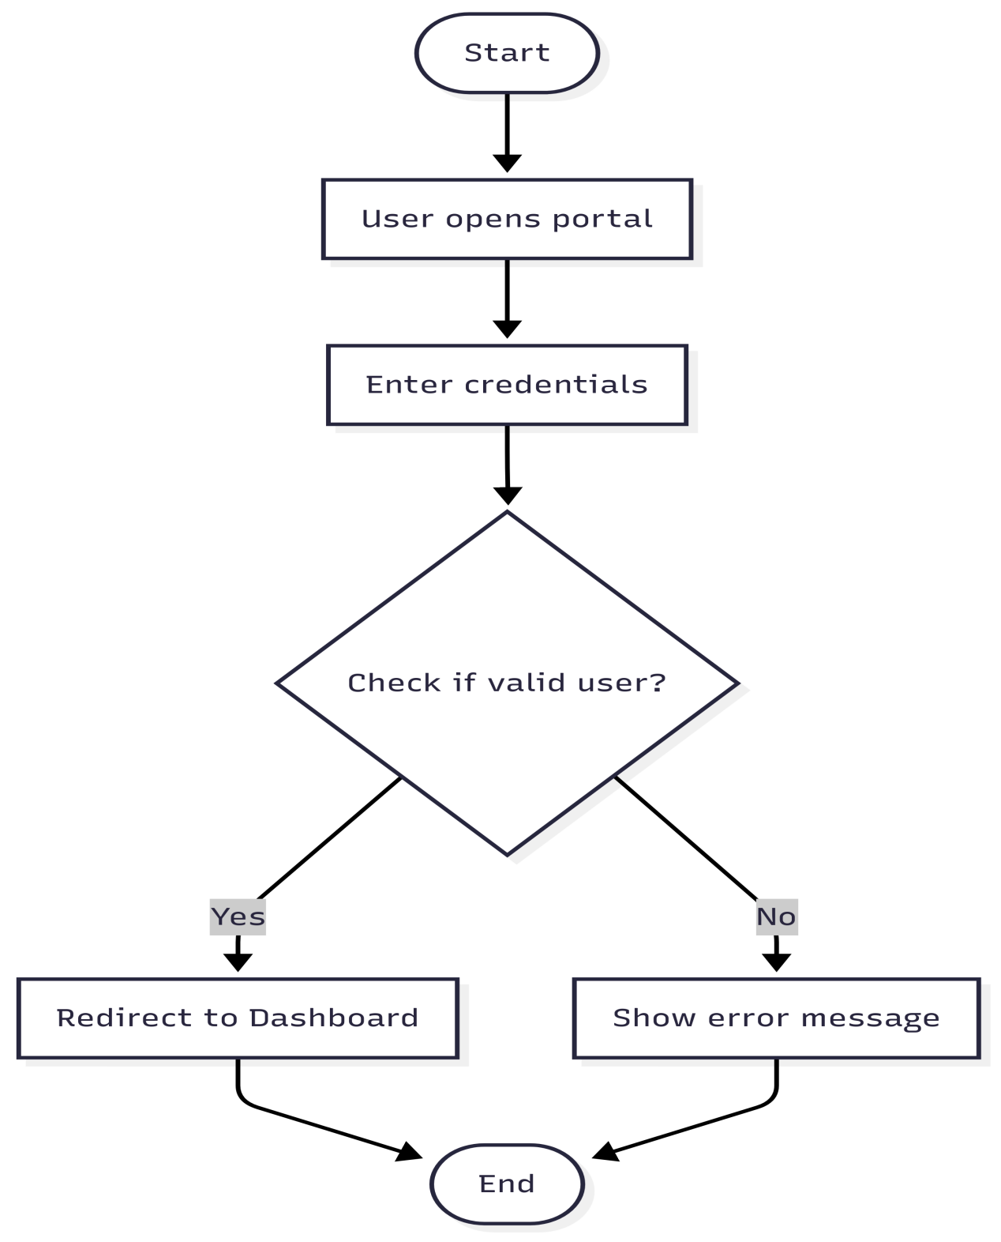

Dashboard Access Based on Role

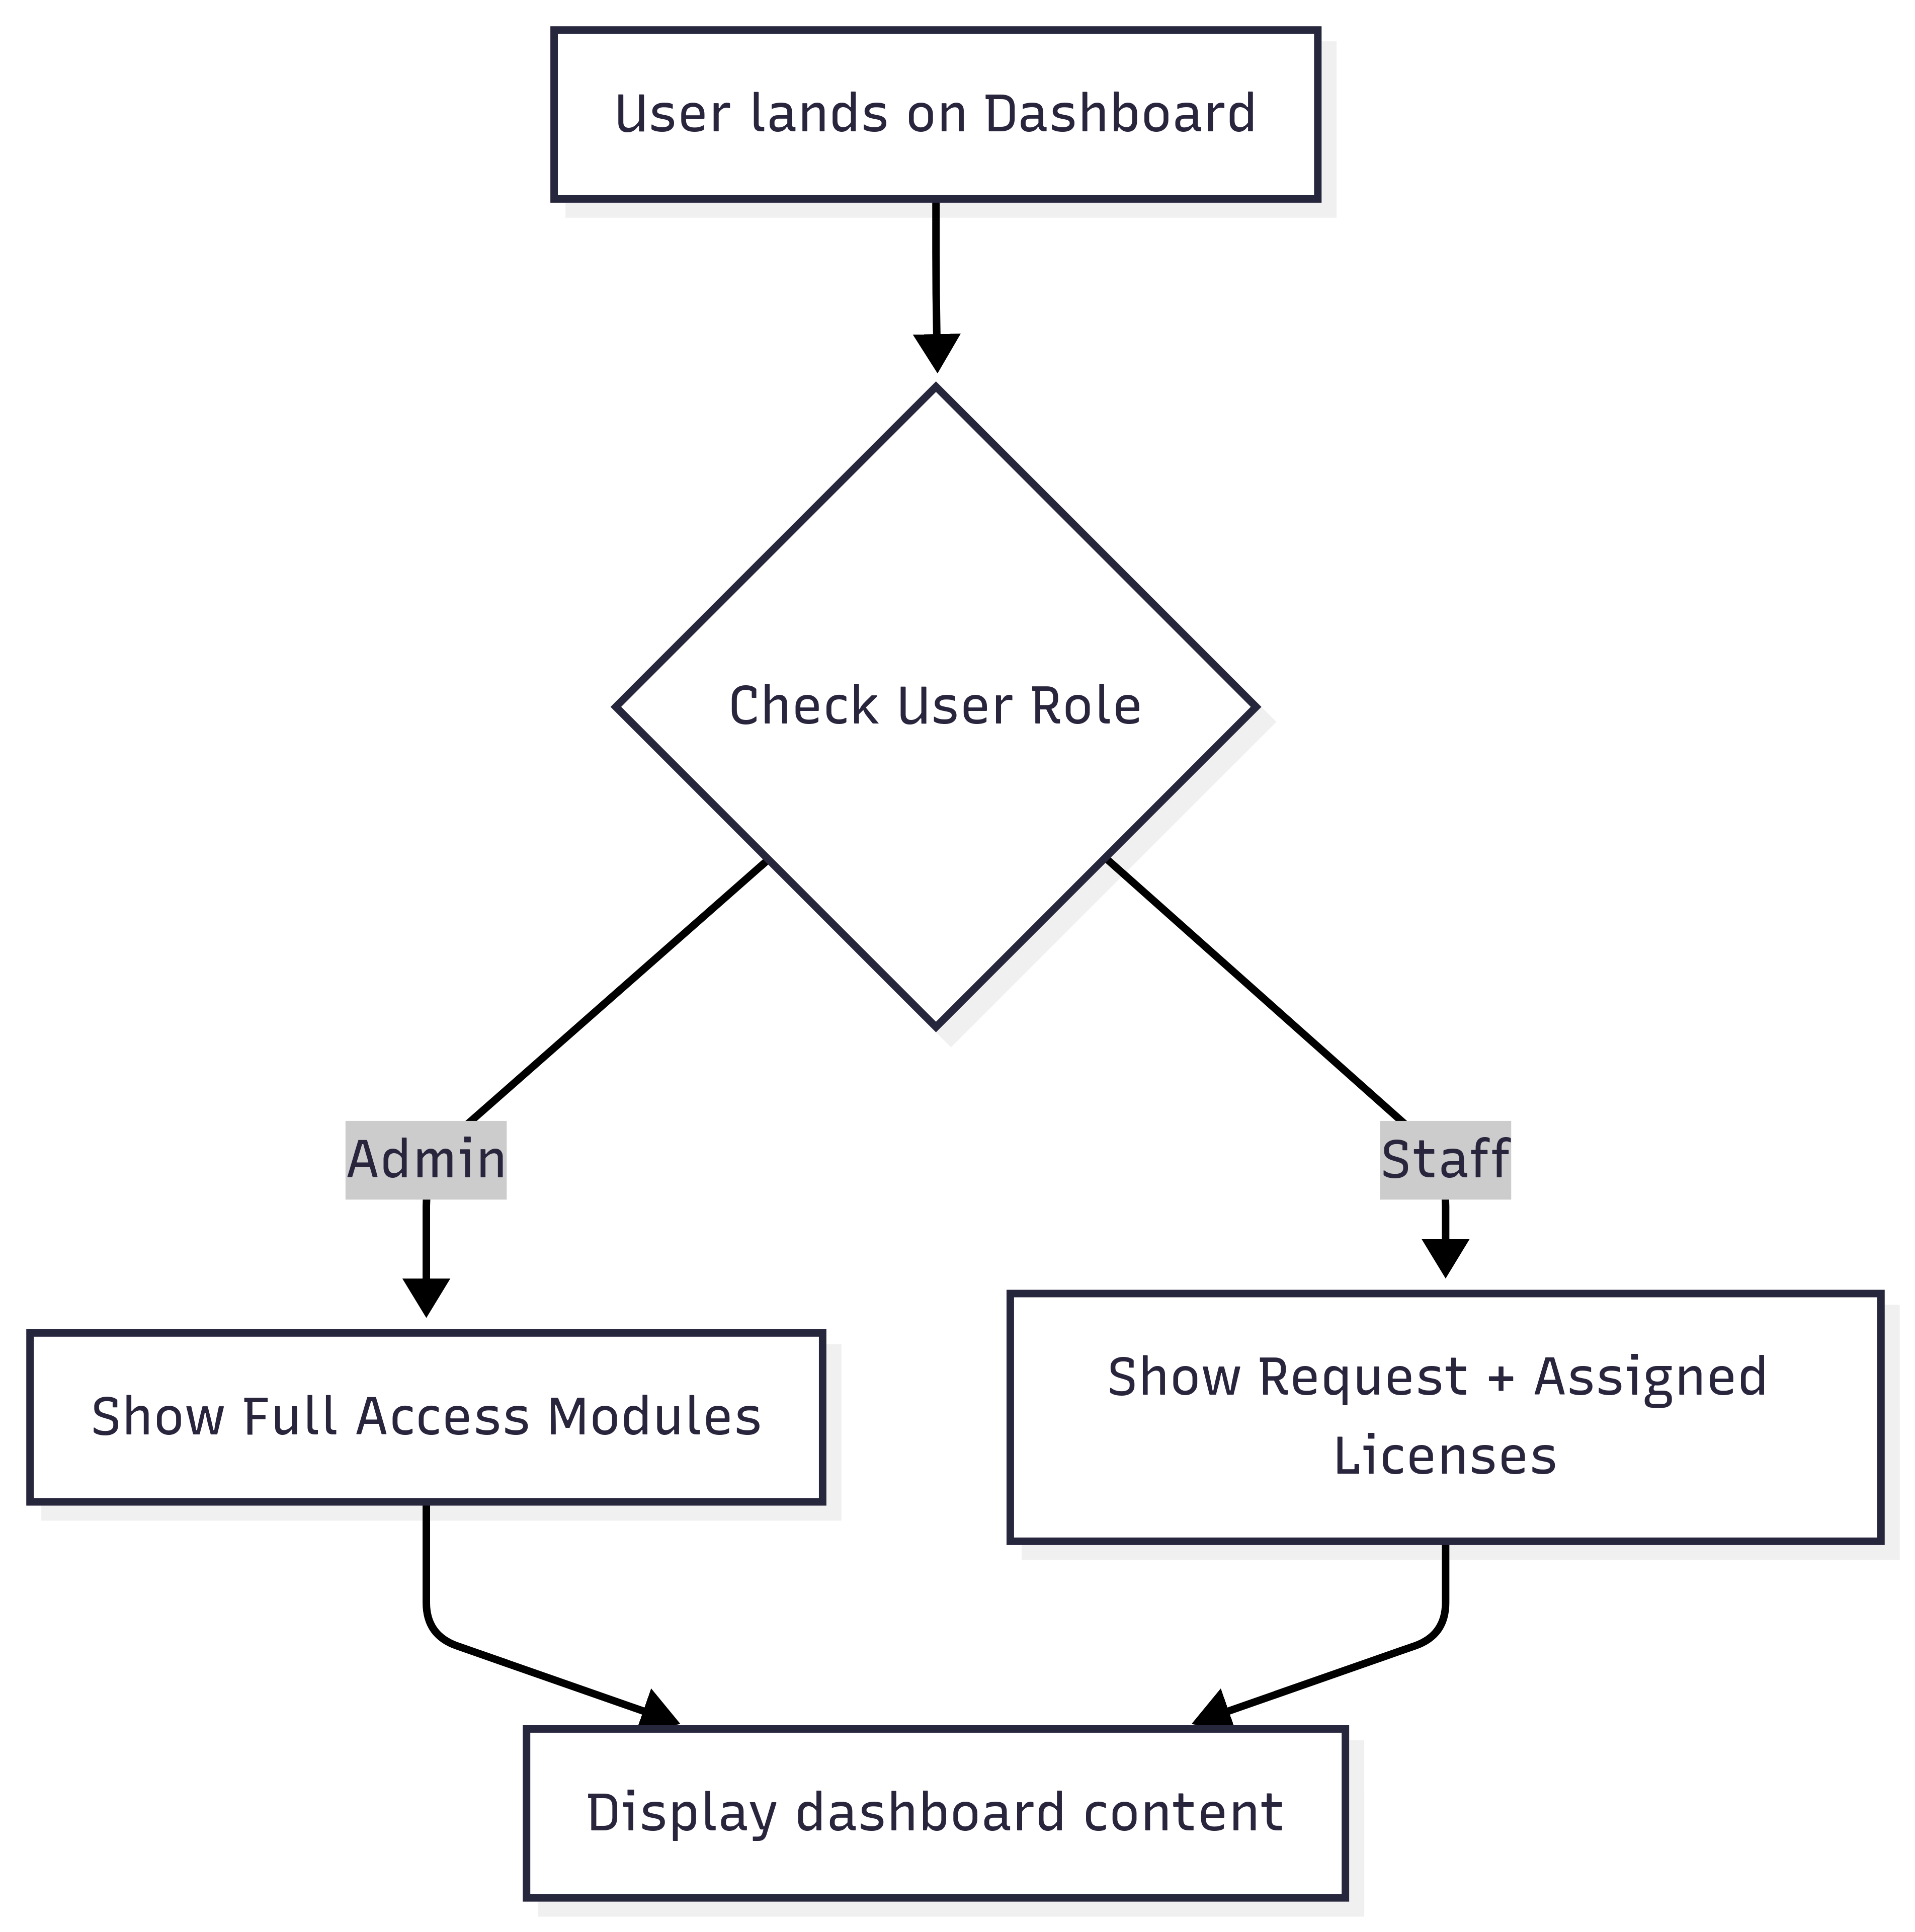

License Request Workflow (Staff)

License Approval (Admin)

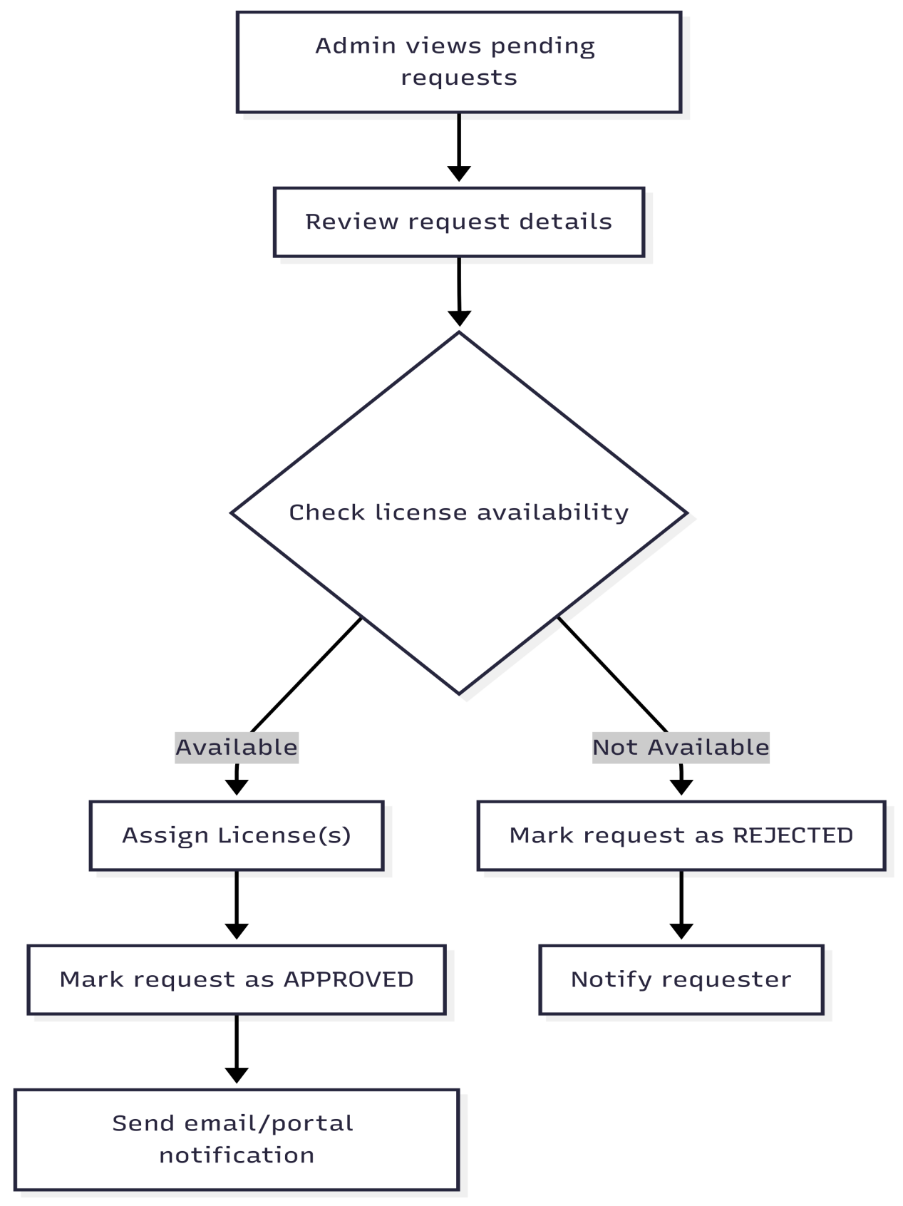

License Assignment & Inventory Update

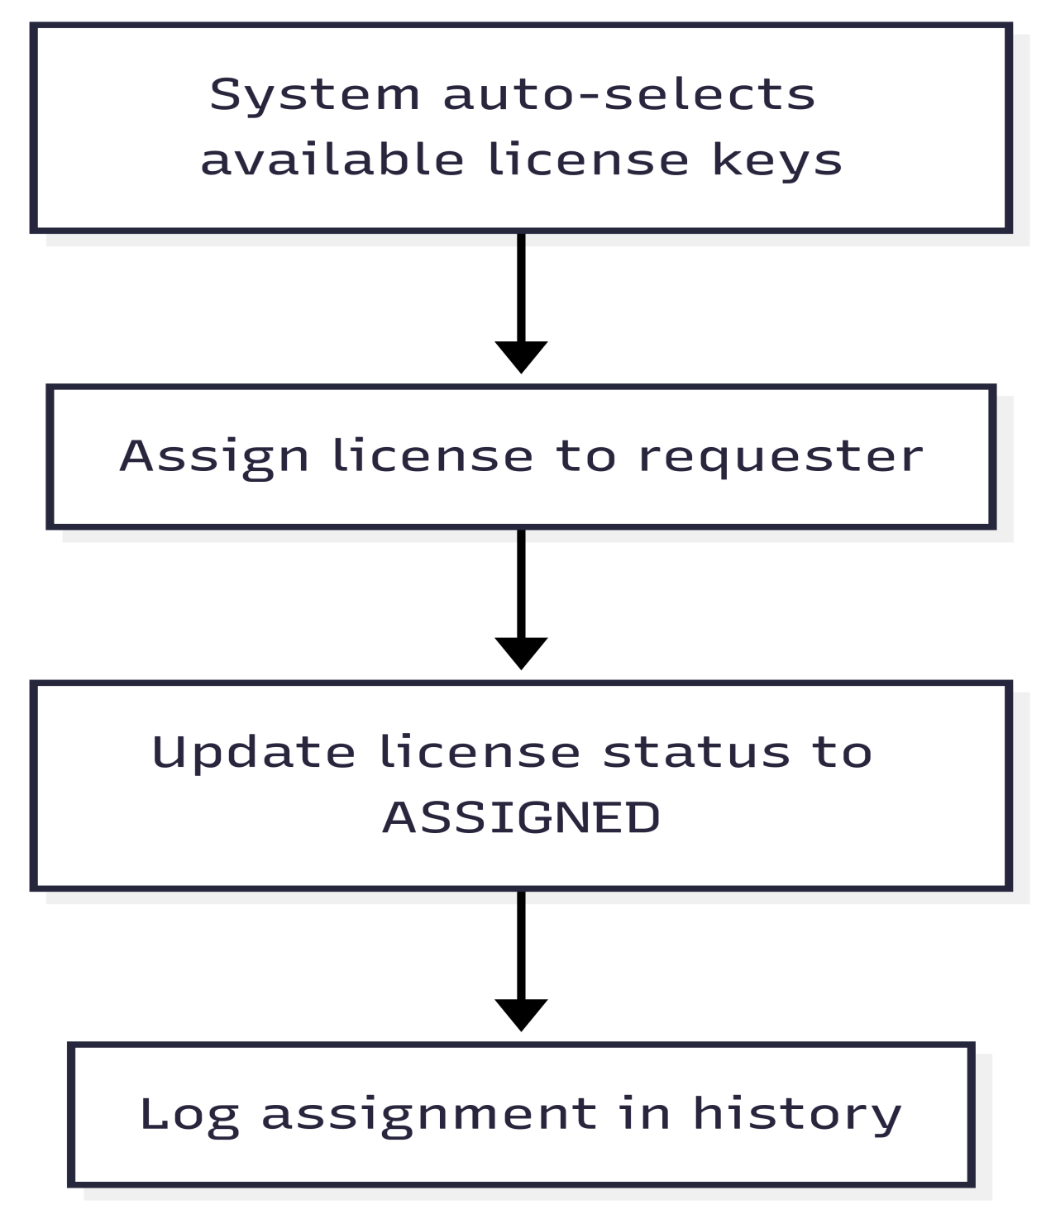

Notification Alerts
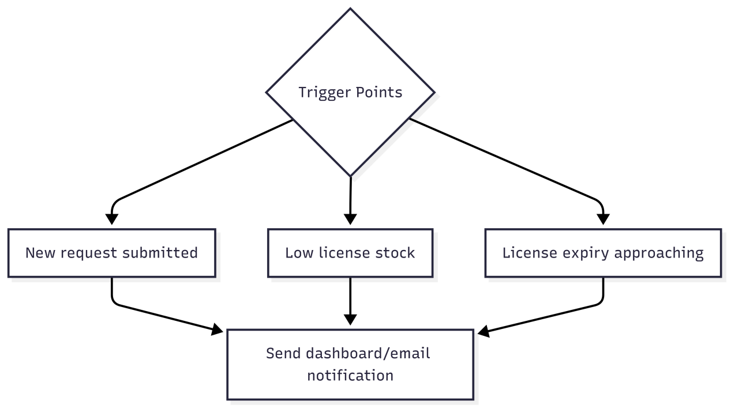

License Expiry Tracking

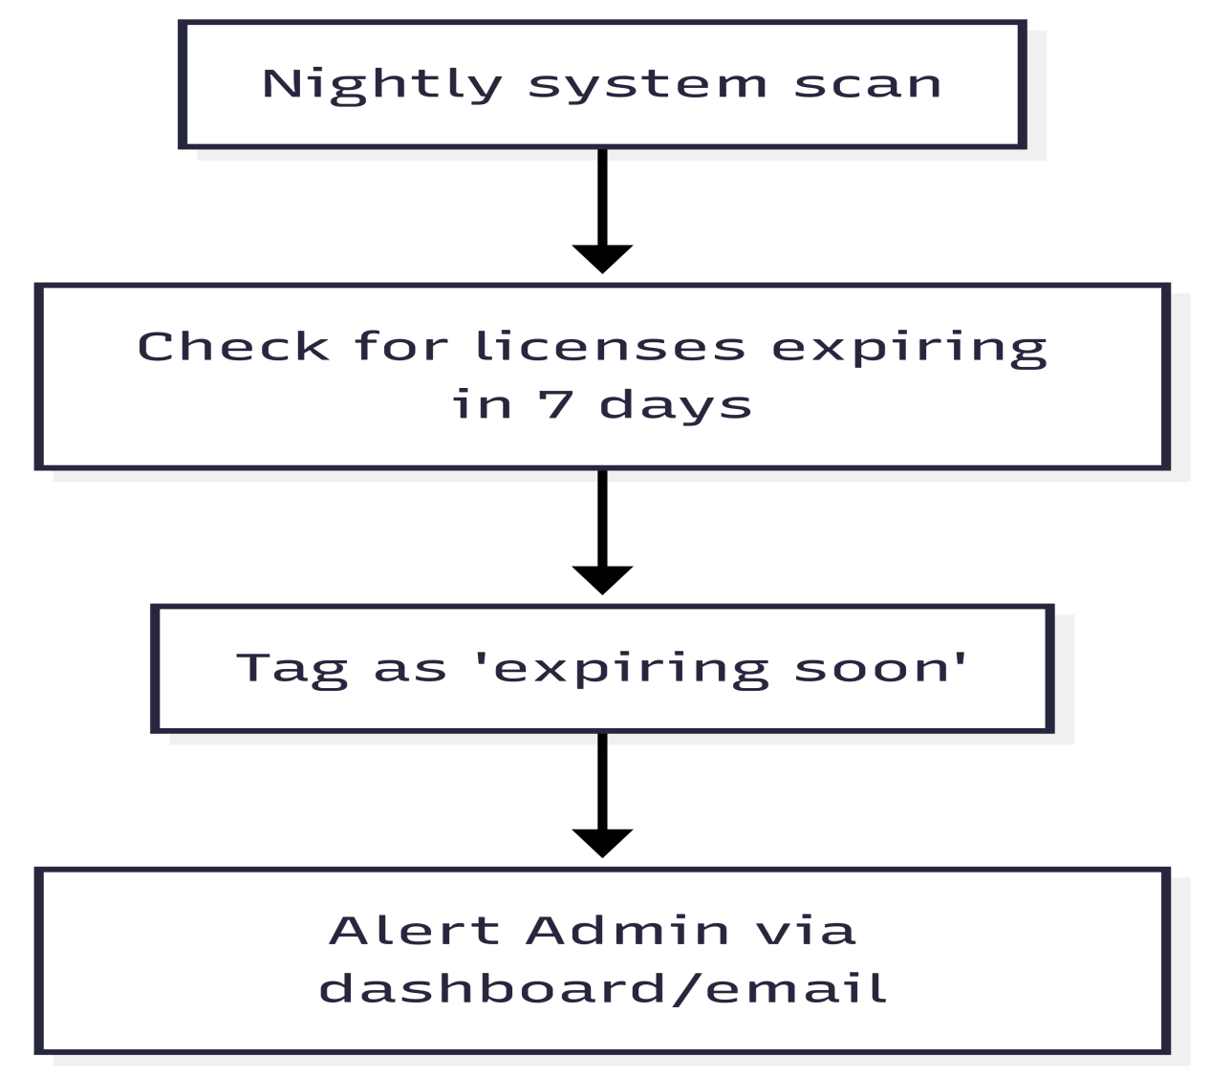

Reporting Module
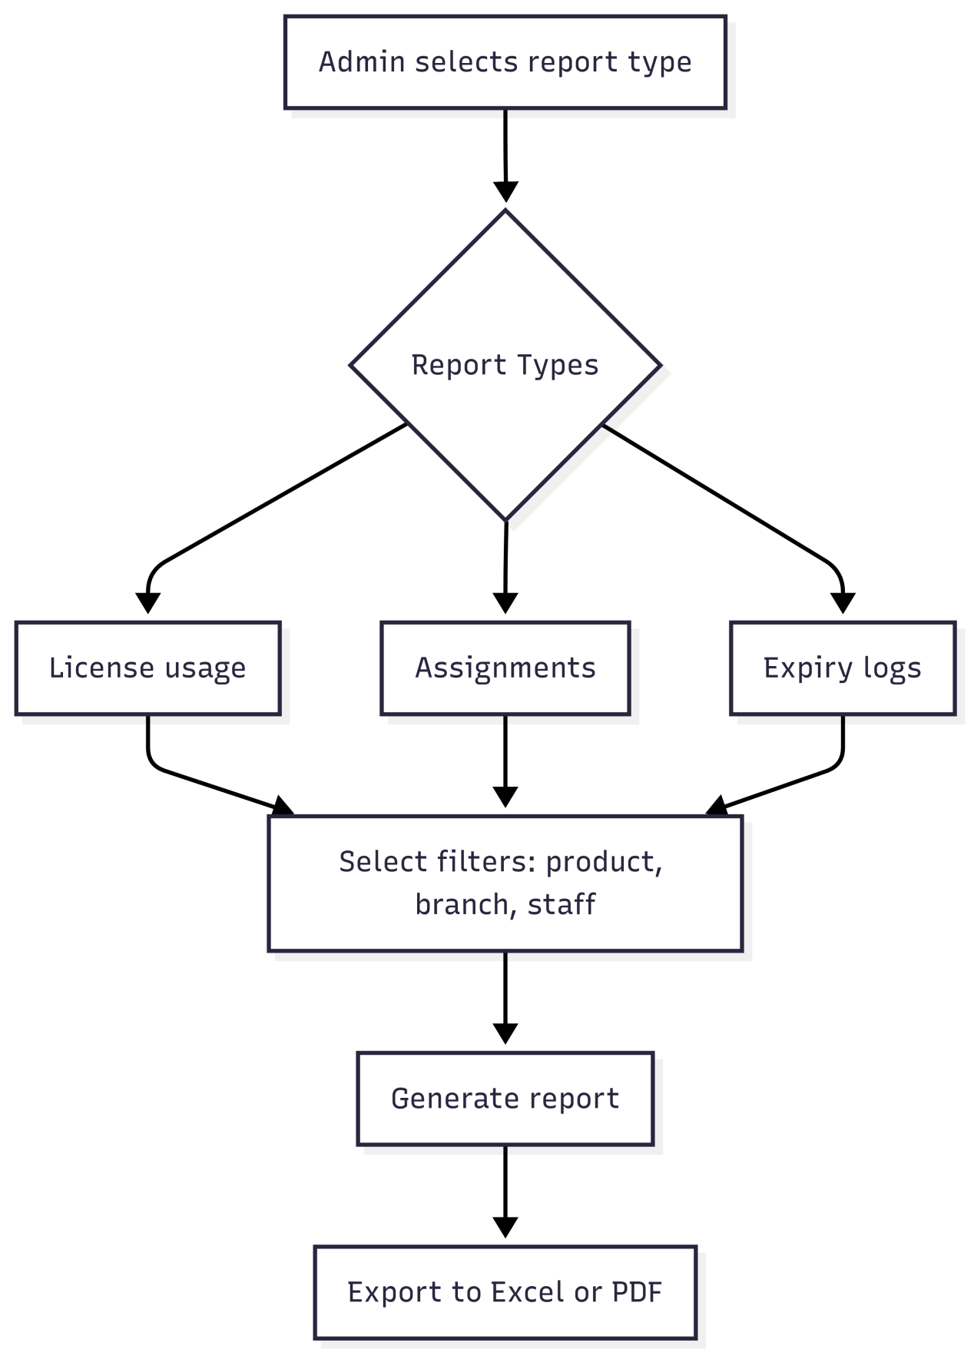

- What is Software License Portal System?

- Welcome Page
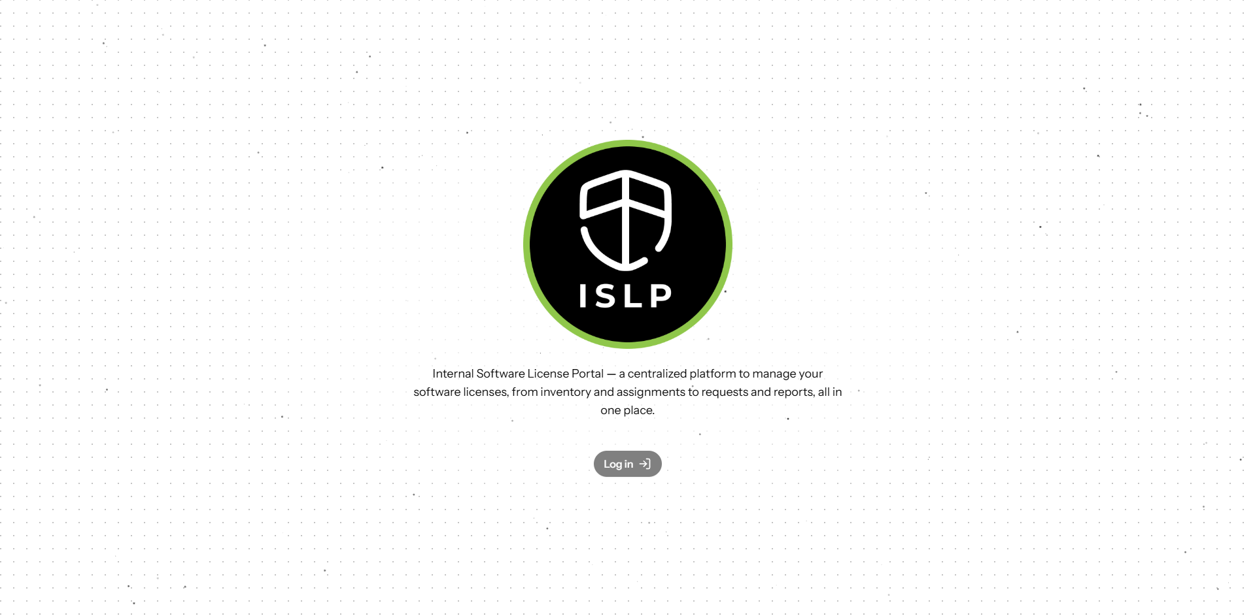
- The Software License Portal login page serves as the primary entry point to the system. It features a clean, user friendly interface with the following elements.

- Logo and Branding prominently display the Software License Portal logo and brand identity to reinforce platform recognition.

- Login Page

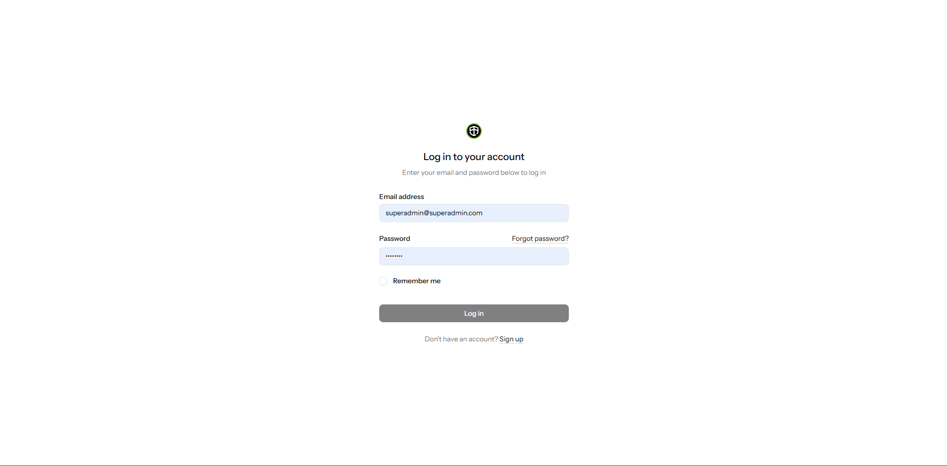

- The Software License Portal is accessible thru the URL https://dev. Software License Portal.able.com.pg/. A login page will appear when the site is visited.

- The Software License Portal login form is the secure gateway for registered users to access the system. It designed with simplicity and accessibility in mind.

- The user can forgot password and direct it to the email.

** Forgot Password **

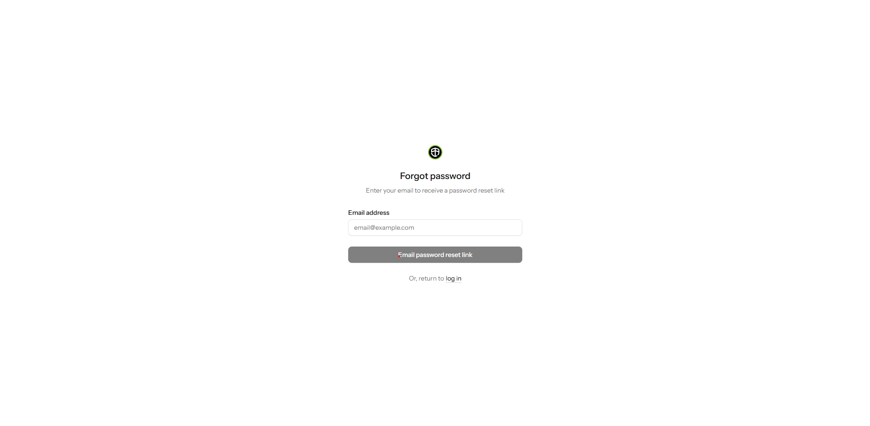

- Registered Email: Only works for emails already in the system.

- Secure Token: The reset link includes a secure token that expires after a certain period.

- Email System: Requires email configuration (SMPT or services like Mailgun or Send Grid).

- User: If the user forgot his/her password then can click the forgot password and direct to the email like google, yahoo etc.

- Dashboard

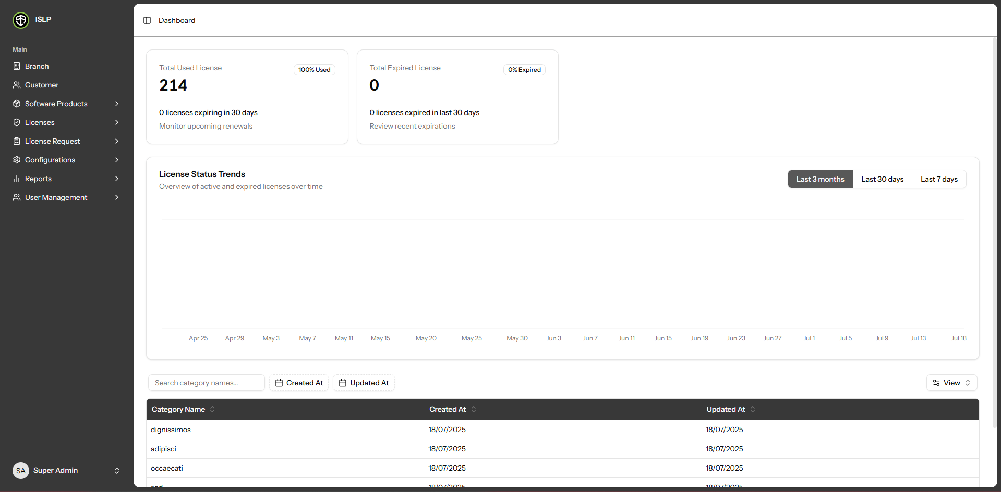

- All user roles must have access to the dashboard. Each user can view their own dashboard based on their assigned access level. Other areas outside their permission are restricted.

- Customer Modules

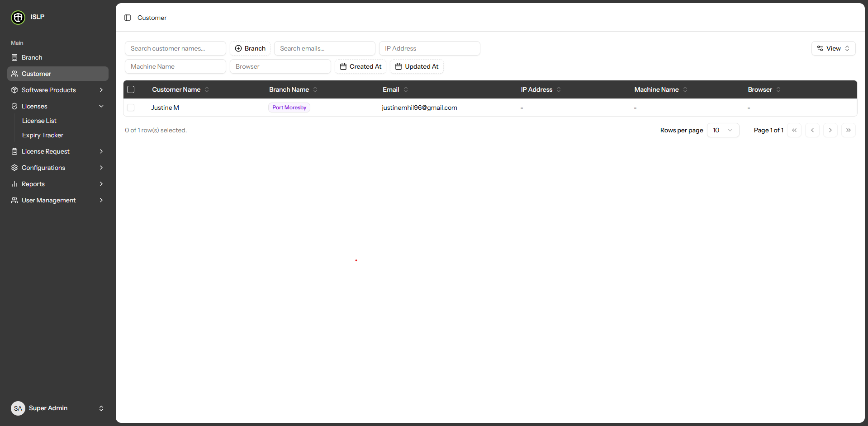

- Customer records are managed through the Customer Table, where you can view, edit, delete, and add new branch entries.

- You can browse the list and detailed view of all existing Customer.

- Users can create new Customer records by providing the necessary details.

- Users can update or modify existing branch information.

- Users can delete Customer records from the table,

- A search box is available to find branches by Customer name.

- You can use the 'Branch Filter' fields to find records based on branch-related criteria.

- A search box is available to find email by User Email.

- A search box is available to find ip address by IP Address.

- A search box is available to find machine name by Machine Name.

- A search box is available to find browser by Browser.

- You can use the 'Created At' or 'Updated At' fields to find records based on when they were created or last updated.

- You can use the View button in the filter column on the right side of the table to hide or unhide columns as needed.

- If you want to export Customer records, simply click the Export button. The exported data will be displayed in tabular format.

- Click the column header if you want to sort in ascending or descending order, or to hide the column.

- The data table includes a pagination filter allowing you to select how many rows to display per page (10, 20, 30, 40, or 50).

- Branch Modules

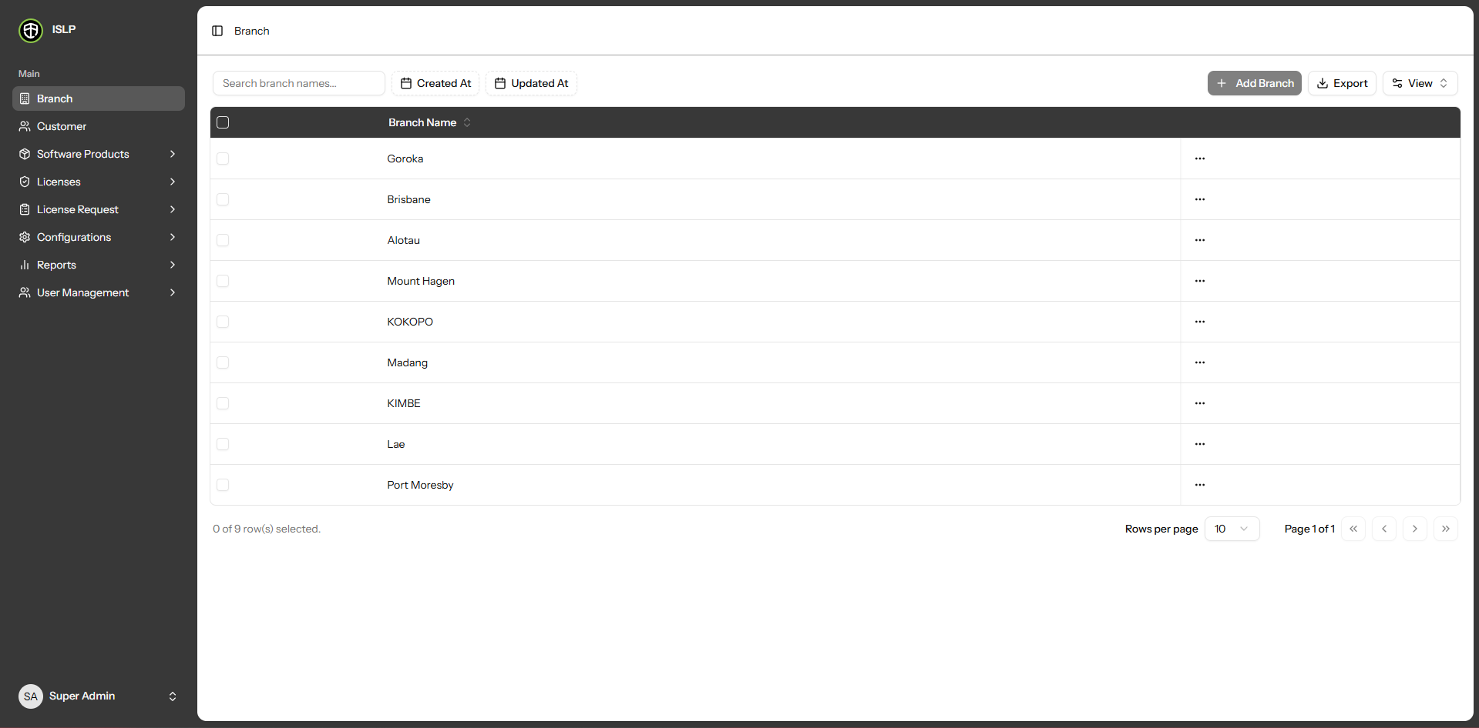

- Branches records are managed through the Branches Table, where you can view, edit, delete, and add new branch entries.

- You can browse the list and detailed view of all existing branches.

- Users can create new branch records by providing the necessary details.

- Users can update or modify existing branch information.

- Users can delete branch records from the table,

- A search box is available to find branches by branch name.

- You can use the 'Created At' or 'Updated At' fields to find records based on when they were created or last updated.

- You can use the View button in the filter column on the right side of the table to hide or unhide columns as needed.

- If you want to export branch records, simply click the Export button. The exported data will be displayed in tabular format.

- Click the column header if you want to sort in ascending or descending order, or to hide the column.

- The data table includes a pagination filter allowing you to select how many rows to display per page (10, 20, 30, 40, or 50).

- Product List Modules

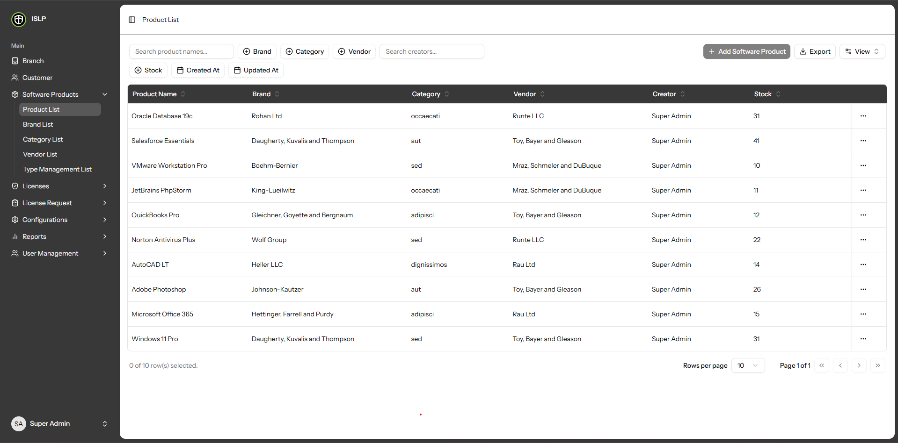

- Product records are managed through the Product Table, where you can view, edit, delete, and add new Product entries.

- You can browse the list and detailed view of all existing Product.

- Users can create new Product records by providing the necessary details.

- Users can update or modify existing Product information.

- Users can delete Product records from the table,

- A search box is available to find Product by Product name

- You can use the 'Branch Filter' fields to find records based on branch criteria.

- You can use the 'Category Filter' fields to find records based on license key criteria.

- You can use the 'Vendor Filter' fields to find records based on expiry date criteria.

- A search box is available to find Creator by Creator

- You can use the 'Stock Filter' fields to find records based on stock criteria.

- You can use the 'Created At' or 'Updated At' fields to find records based on when they were created or last updated.

- You can use the View button in the filter column on the right side of the table to hide or unhide columns as needed.

- If you want to export Product records, simply click the Export button. The exported data will be displayed in tabular format.

- Click the column header if you want to sort in ascending or descending order, or to hide the column

To new a software product, click the Add software product button Then, fill in the following fields.

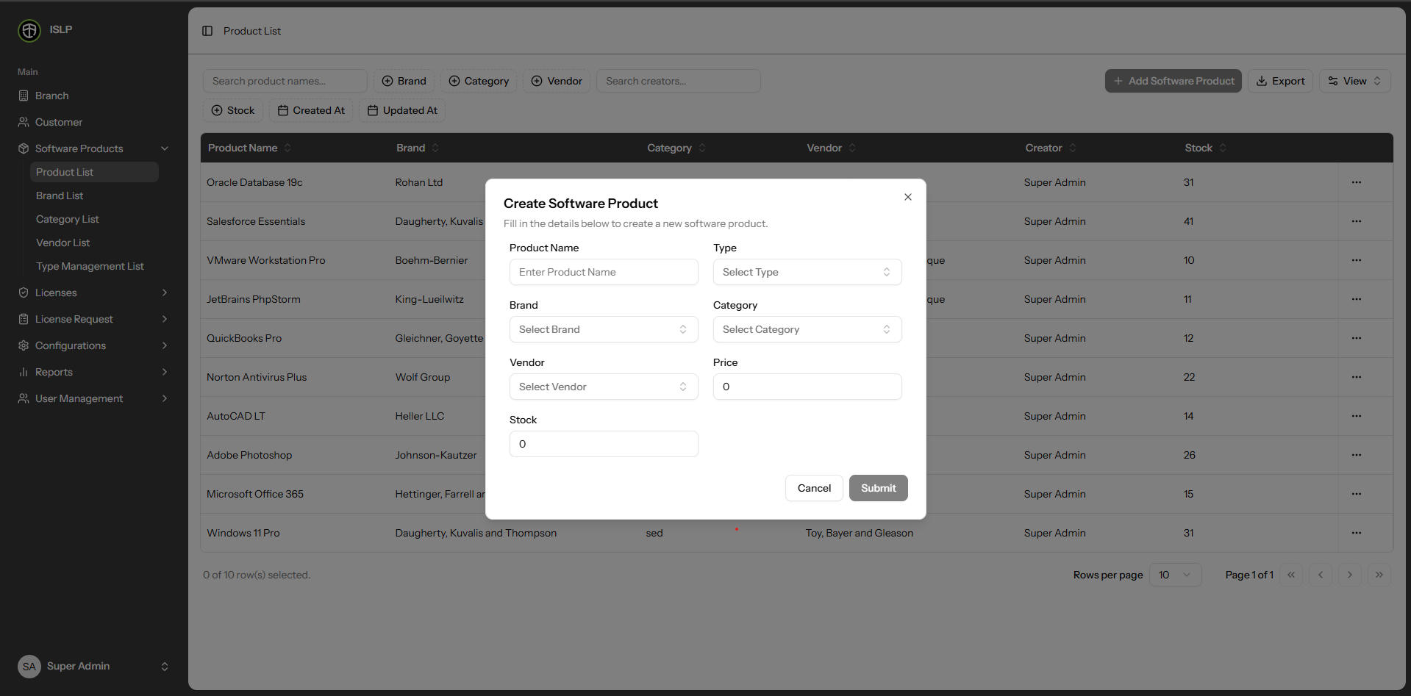

* Product Name - Input the product name.

* Type - After input the product name, choose the type from the dropdown.

* Brand - After selecting the type, choose the branch from the dropdown.

* Category - After selecting the brand, choose the category from the dropdown.

* Vendor - After selecting the category, choose the vendor from the dropdown.

* Vendor - After selecting the category, choose the vendor from the dropdown.

* Vendor - After selecting the category, choose the vendor from the dropdown.

* Price – Enter the price.

* Stock – Enter the stock quantity.

To update a software product, click the Edit button. Then, edit in the following fields.

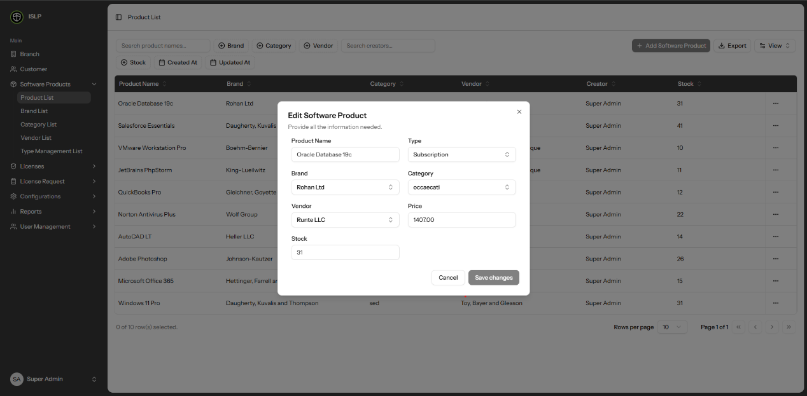

* Product Name - Input the product name.

* Type - After input the product name, choose the type from the dropdown.

* Brand - After selecting the type, choose the branch from the dropdown.

* Category - After selecting the brand, choose the category from the dropdown.

* Vendor - After selecting the category, choose the vendor from the dropdown.

* Vendor - After selecting the category, choose the vendor from the dropdown.

* Vendor - After selecting the category, choose the vendor from the dropdown.

* Price – Enter the price.

* Stock – Enter the stock quantity.

- Brand List Modules

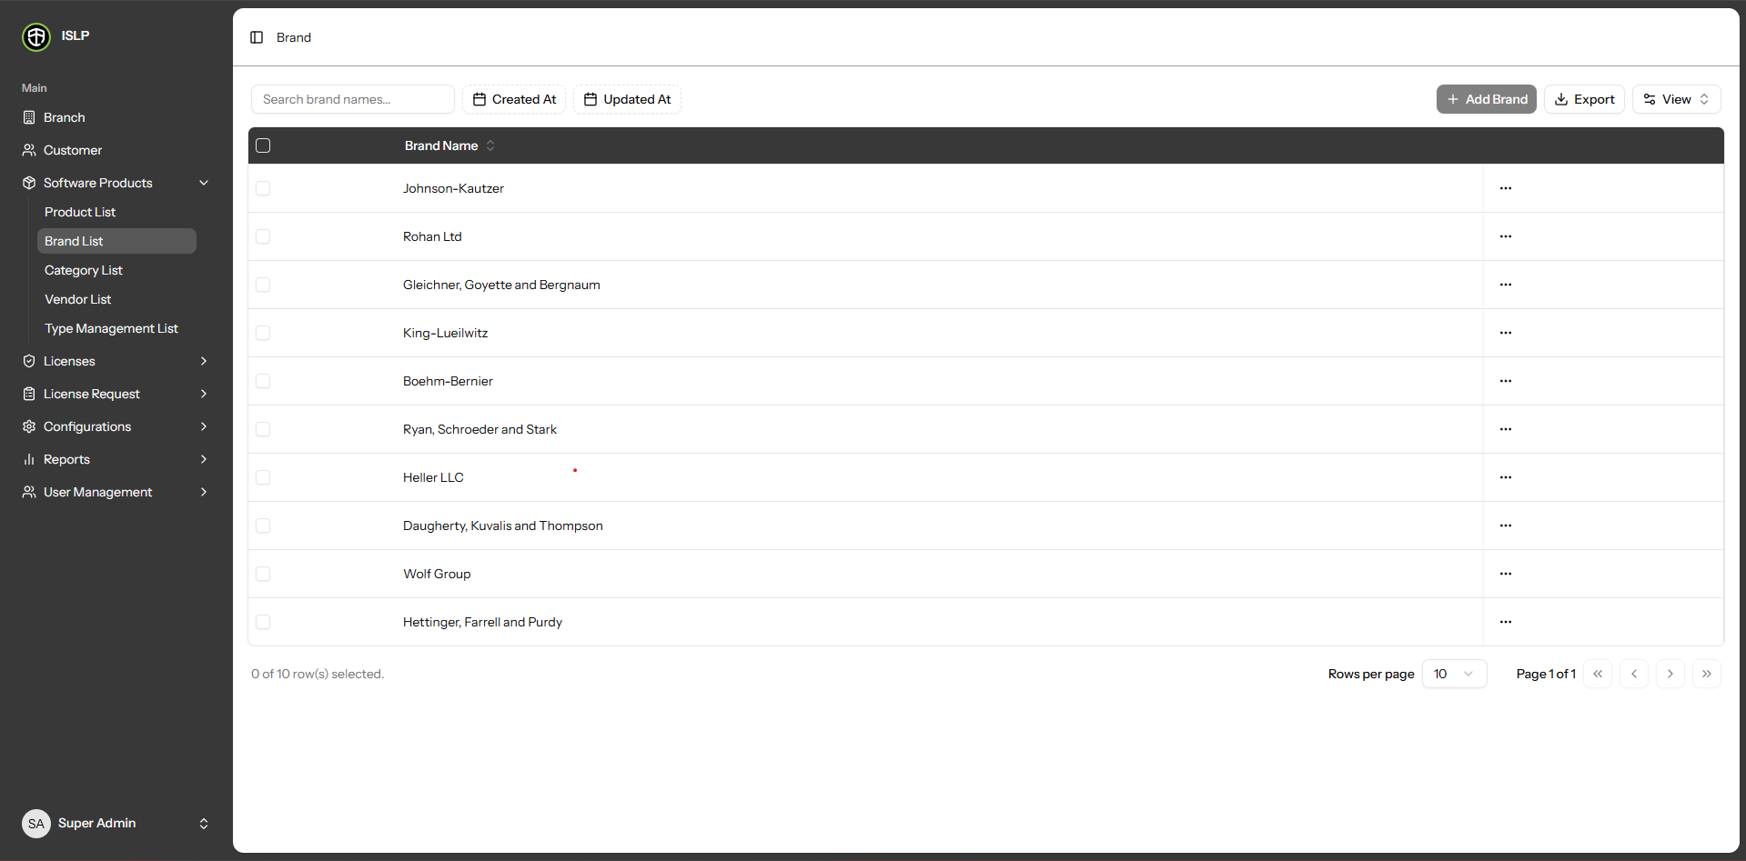

- Brand records are managed through the Brand Table, where you can view, edit, delete, and add new Brand entries.

- You can browse the list and detailed view of all existing Brand.

- Users can create new Brand records by providing the necessary details.

- Users can update or modify existing Brand information.

- Users can delete Brand records from the table,

- A search box is available to find Brand by Brand name

- You can use the 'Created At' or 'Updated At' fields to find records based on when they were created or last updated.

- You can use the View button in the filter column on the right side of the table to hide or unhide columns as needed.

- If you want to export Product records, simply click the Export button. The exported data will be displayed in tabular format.

- Click the column header if you want to sort in ascending or descending order, or to hide the column.

- The data table includes a pagination filter allowing you to select how many rows to display per page (10, 20, 30, 40, or 50).

- Category List Modules

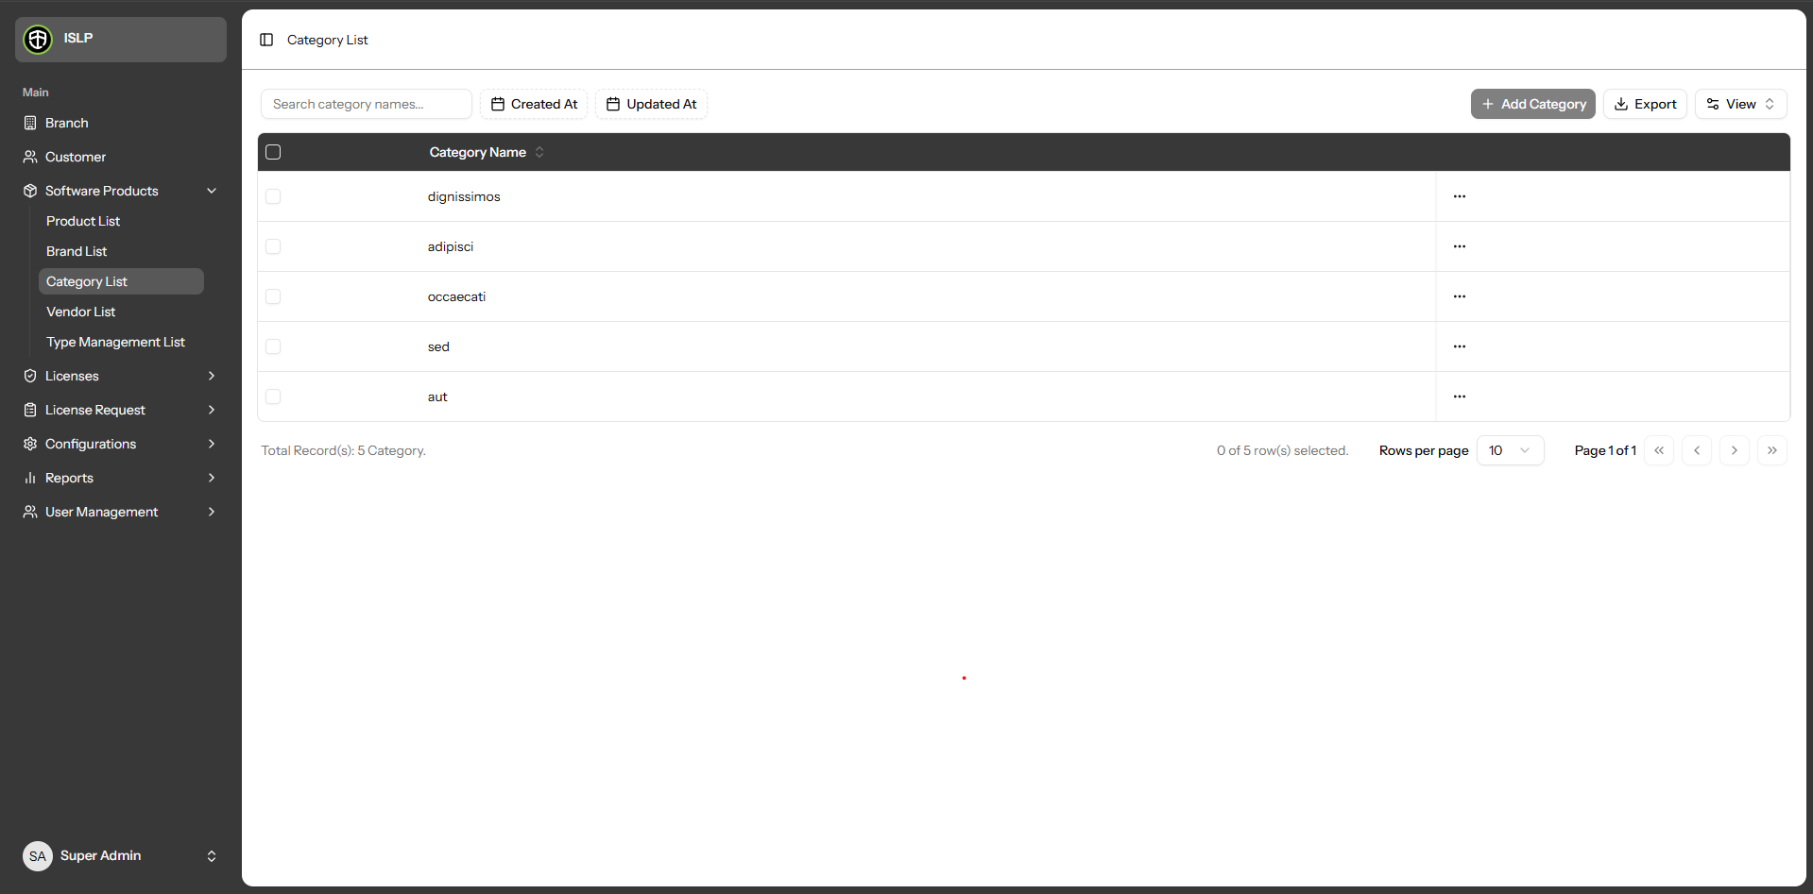

- Category records are managed through the Category Table, where you can view, edit, delete, and add new Brand entries.

- You can browse the list and detailed view of all existing Category.

- Users can create new Category records by providing the necessary details.

- Users can update or modify existing Category information.

- Users can delete Category records from the table,

- A search box is available to find Category by Category name

- You can use the 'Created At' or 'Updated At' fields to find records based on when they were created or last updated.

- You can use the View button in the filter column on the right side of the table to hide or unhide columns as needed.

- If you want to export Category records, simply click the Export button. The exported data will be displayed in tabular format.

- Click the column header if you want to sort in ascending or descending order, or to hide the column.

- The data table includes a pagination filter allowing you to select how many rows to display per page (10, 20, 30, 40, or 50).

- Vendor List Modules

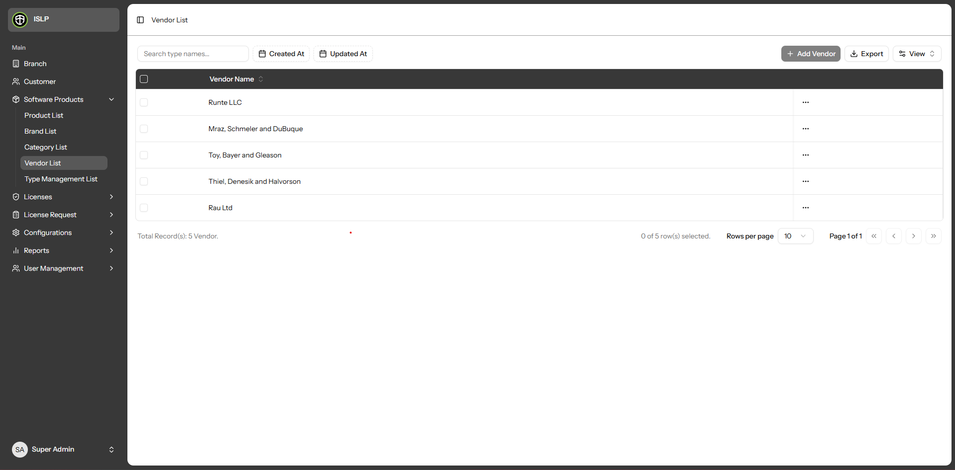

- Vendor records are managed through the Vendor Table, where you can view, edit, delete, and add new Vendor entries.

- You can browse the list and detailed view of all existing Vendor.

- Users can create new Vendor records by providing the necessary details.

- Users can update or modify existing Vendor information.

- Users can delete Vendor records from the table,

- A search box is available to find Vendor by Vendor name

- You can use the 'Created At' or 'Updated At' fields to find records based on when they were created or last updated.

- You can use the View button in the filter column on the right side of the table to hide or unhide columns as needed.

- If you want to export Vendor records, simply click the Export button. The exported data will be displayed in tabular format.

- Click the column header if you want to sort in ascending or descending order, or to hide the column.

- The data table includes a pagination filter allowing you to select how many rows to display per page (10, 20, 30, 40, or 50).

- Type Management List Modules

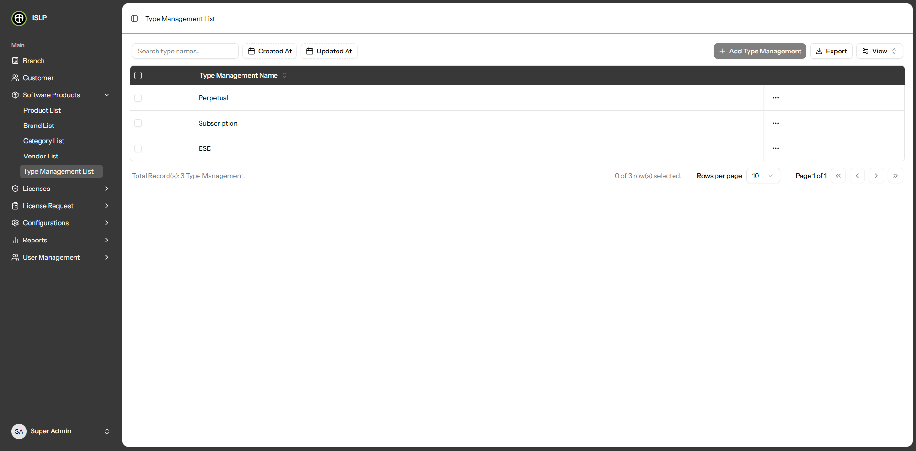

- Type Management records are managed through the Type Management Table, where you can view, edit, delete, and add new Vendor entries.

- You can browse the list and detailed view of all existing Type Management.

- Users can create new Type Management records by providing the necessary details.

- Users can update or modify existing Type Management information.

- Users can delete Type Management records from the table,

- A search box is available to find Type Management by Type Management name

- You can use the 'Created At' or 'Updated At' fields to find records based on when they were created or last updated.

- You can use the View button in the filter column on the right side of the table to hide or unhide columns as needed.

- If you want to export Type Management records, simply click the Export button. The exported data will be displayed in tabular format.

- Click the column header if you want to sort in ascending or descending order, or to hide the column.

- The data table includes a pagination filter allowing you to select how many rows to display per page (10, 20, 30, 40, or 50).

- License List Modules

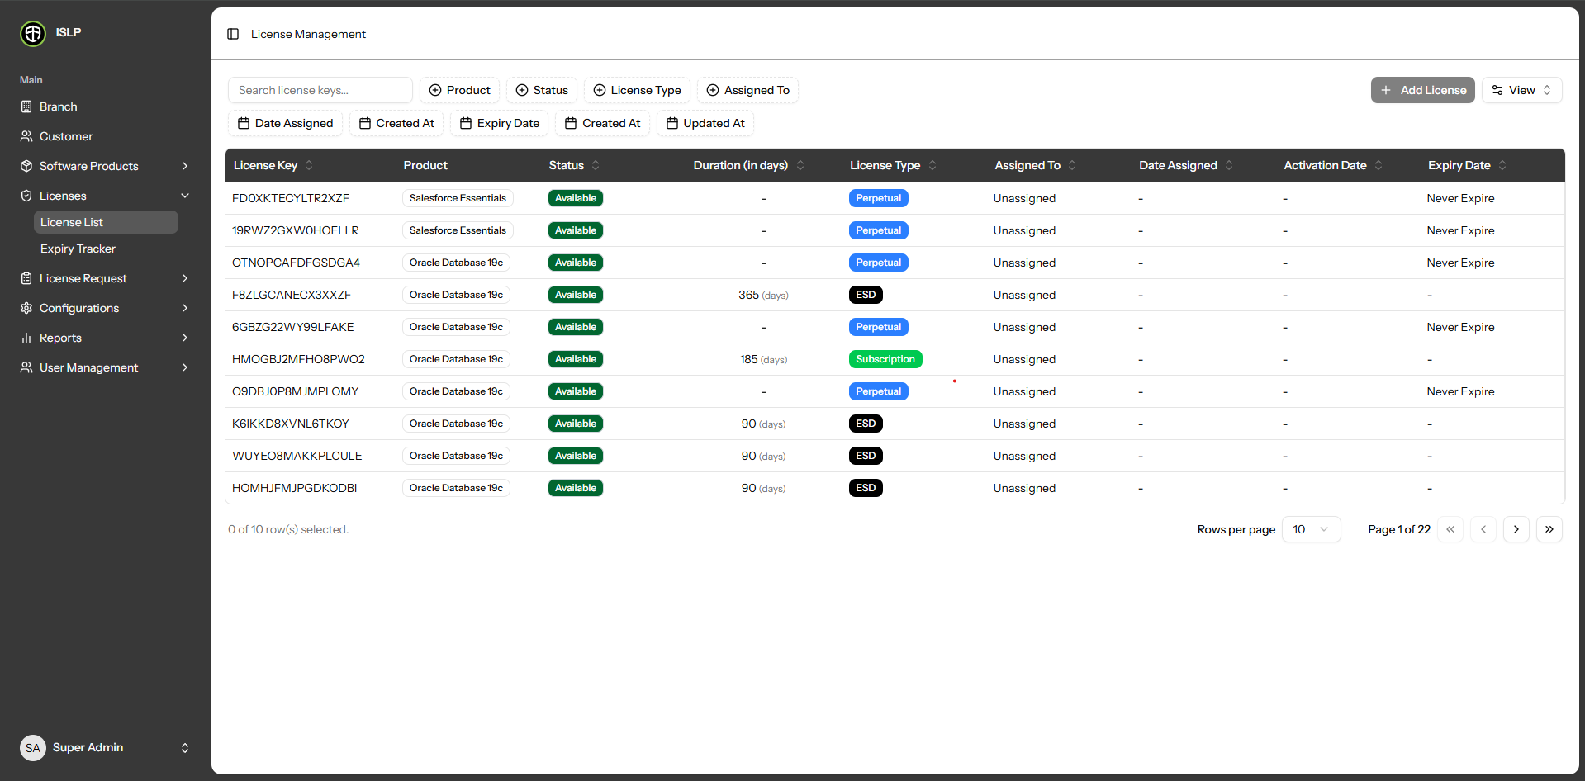

- License records are managed through the License Table, where you can view, and add new License entries.

- You can browse the list and detailed view of all existing License.

- Users can create new License records by providing the necessary details.

- Users can update or modify existing License information.

- Users can delete License records from the table,

- A search box is available to find License by License Key.

- You can use the 'Created At' or 'Updated At' fields to find records based on when they were created or last updated.

- You can use the 'Product Filter' fields to find records based on product criteria.

- You can use the 'Status Filter' fields to find records based on status criteria.

- You can use the 'License Type Filter' fields to find records based on license type criteria.

- You can use the 'Assigned to Filter' fields to find records based on assigned to criteria.

- You can use the 'Date Assigned Filter' fields to find records based on date assigned criteria.

- You can use the 'Expiry Date Filter' fields to find records based on expiry date-related criteria.

- You can use the View button in the filter column on the right side of the table to hide or unhide columns as needed.

- Click the column header if you want to sort in ascending or descending order, or to hide the column.
To new a license, click the Add license button Then, fill in the following fields.

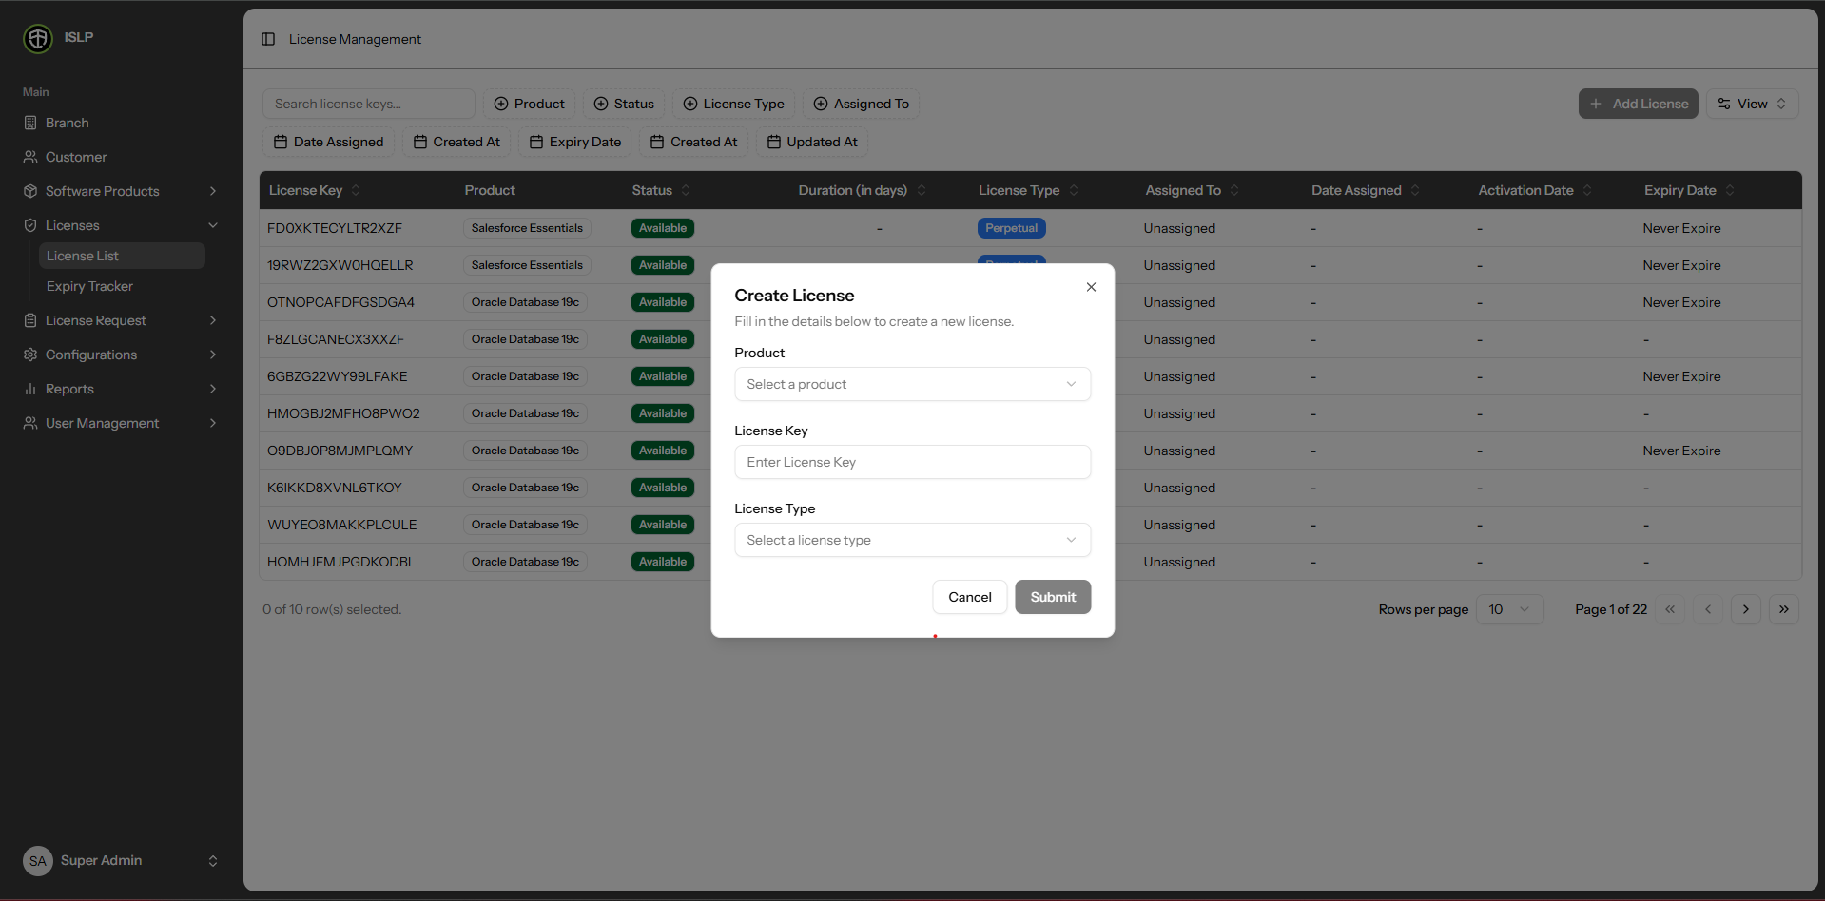

* Product - Select the product, then choose the product from the dropdown

* License Key - Enter the license key.

* License Type - Select the license type, then choose the license type from the dropdown

- Expiry Tracker Modules

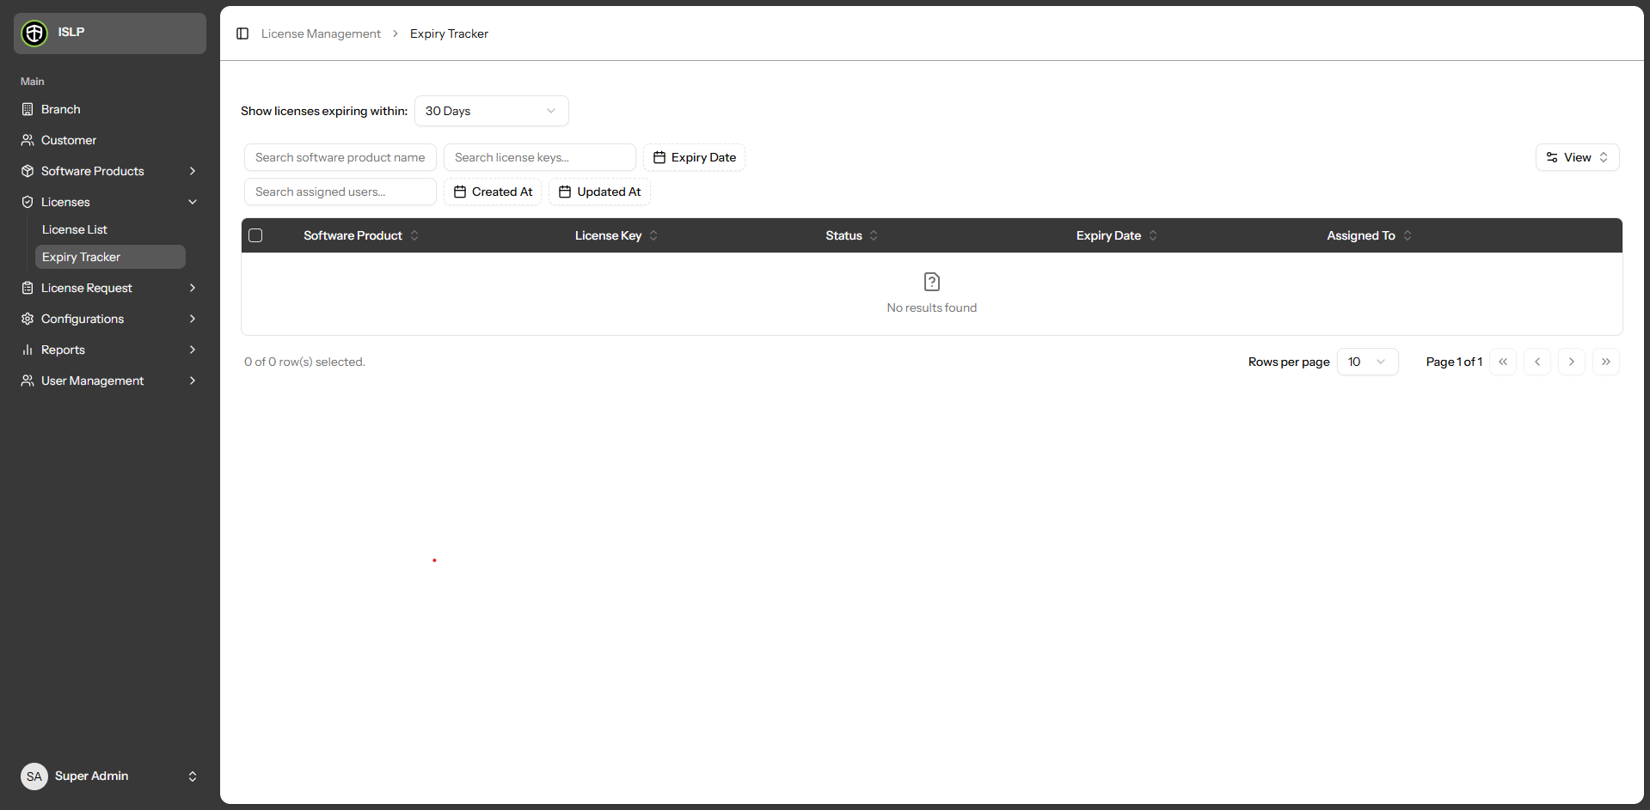

- Expiry Tracker records are managed through the Expiry Tracker Table, where you can view data.

- You can browse the list and detailed view of all existing Expiry Tracker.

- Filter by license expiration: 30 days, 90 days, 120 days, 1 year

- You can use the 'Software Product Filter' fields to find records based on software product criteria.

- You can use the 'License Key Filter' fields to find records based on license key criteria.

- You can use the 'Expiry Date Filter' fields to find records based on expiry date criteria.

- You can use the 'Created At' or 'Updated At' fields to find records based on when they were created or last updated.

- You can use the View button in the filter column on the right side of the table to hide or unhide columns as needed.

- Click the column header if you want to sort in ascending or descending order, or to hide the column.

- The data table includes a pagination filter allowing you to select how many rows to display per page (10, 20, 30, 40, or 50).

- Request Form Modules

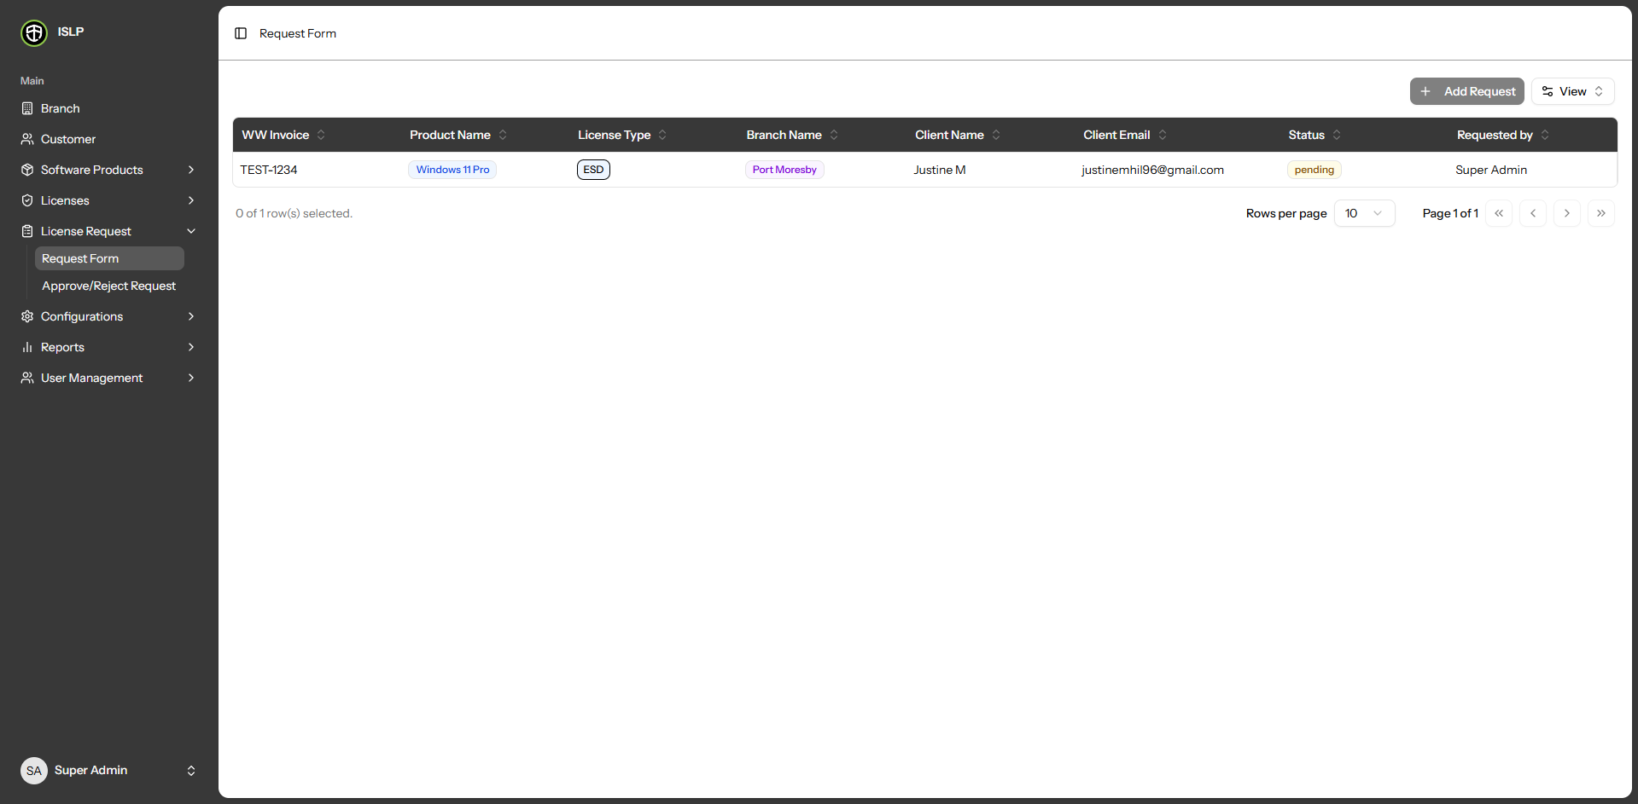

- Request Form records are managed through the Request Form Table, where you can view and add new Request Form entries.

- You can browse the list and detailed view of all existing Request Form

- You can use the View button in the filter column on the right side of the table to hide or unhide columns as needed.

- Click the column header if you want to sort in ascending or descending order, or to hide the column.

- The data table includes a pagination filter allowing you to select how many rows to display per page (10, 20, 30, 40, or 50).

To new a request form, click the Add Request button Then, fill in the following fields.

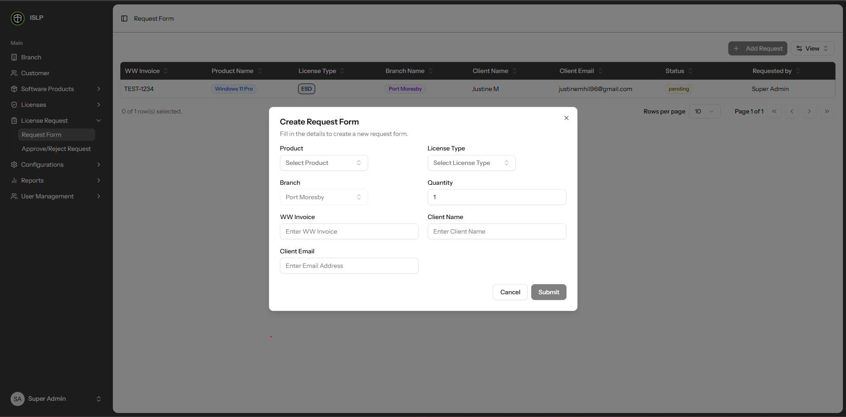

* Product - Select the product, choose the product from the dropdown.

* License Type - After selecting the product, choose the license type from the dropdown.

* Quantity – Enter the quantity.

* WW Invoice – Input the WW invoice.

* Client Name – Input the client’s name.

* Client Email - Input the client’s email.

- Approve / Reject Request Modules

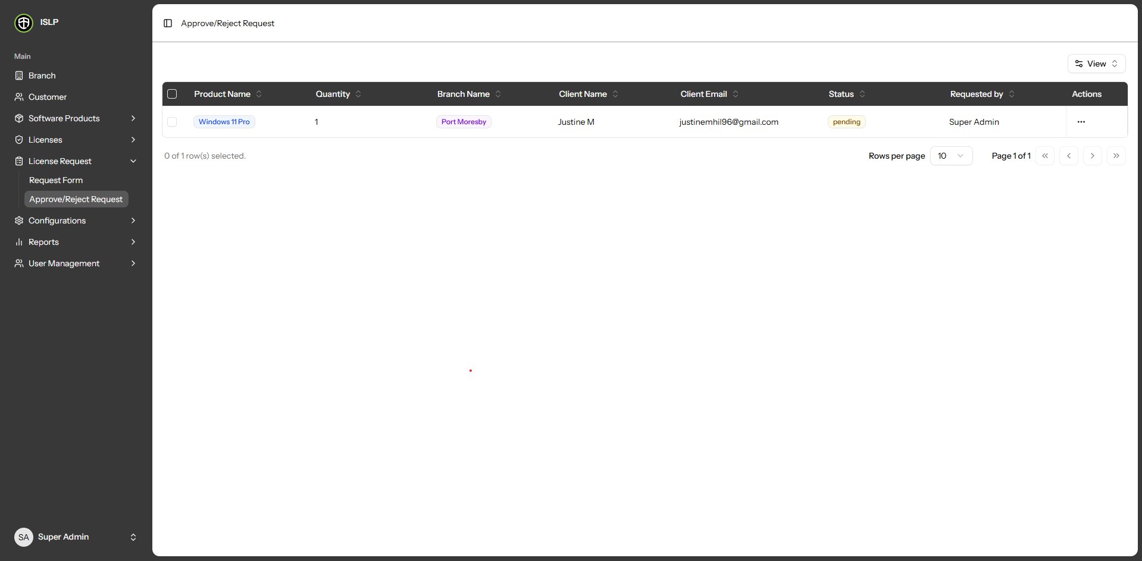

- Approve / Reject Request records are managed through the Approve / Reject Request Table, where you can view data.

- You can browse the list and detailed view of all existing Approve / Reject Request

- You can use the View button in the filter column on the right side of the table to hide or unhide columns as needed.

- Click the column header if you want to sort in ascending or descending order, or to hide the column.

- The data table includes a pagination filter allowing you to select how many rows to display per page (10, 20, 30, 40, or 50).

- Expiry Notification Rules Modules

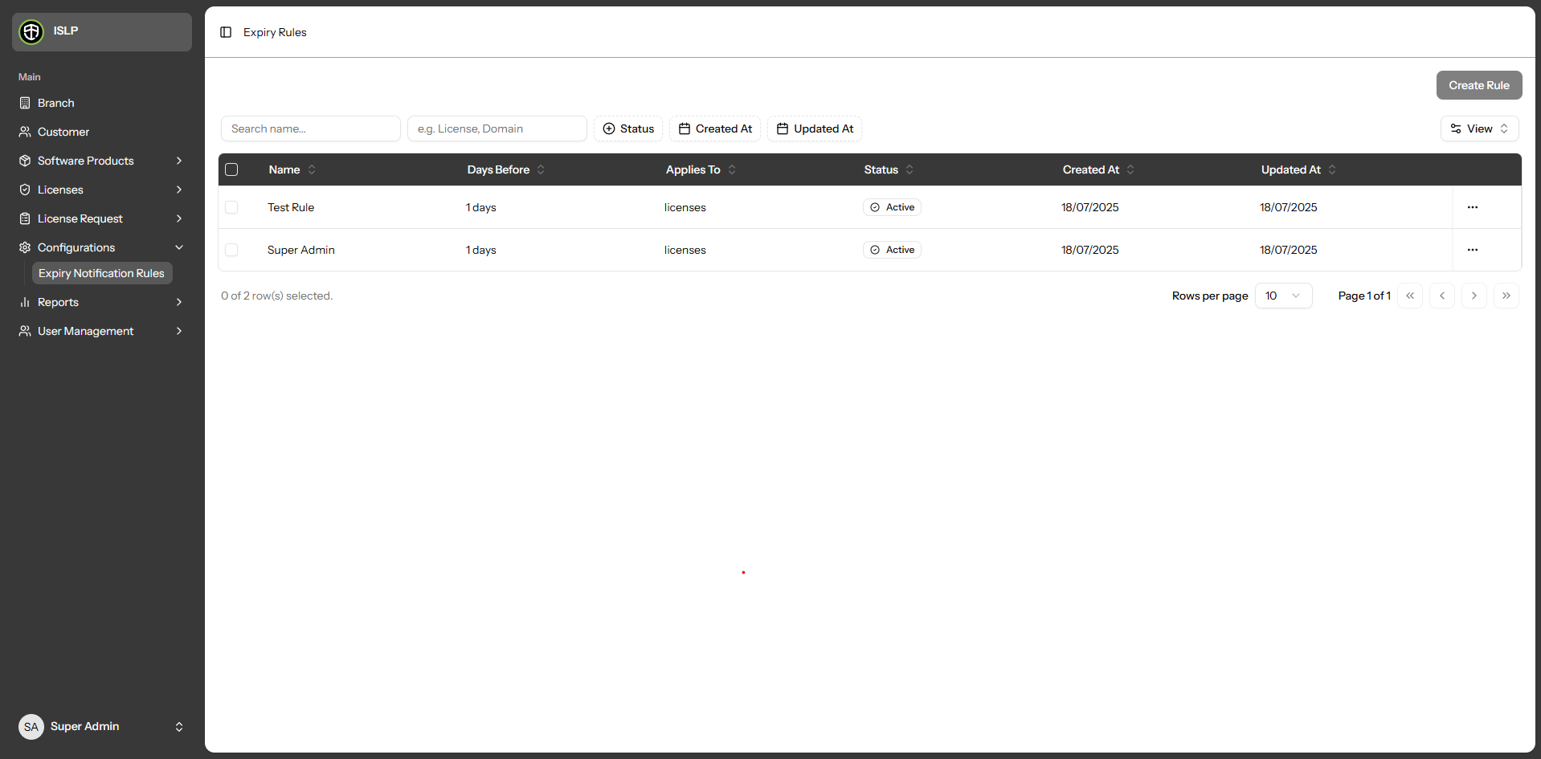

- Expiry Notification Rules are managed through the Expiry Notification Rules Table, where you can view, and add new Expiry Notification Rules entries.

- You can browse the list and detailed view of all existing Expiry Notification Rules.

- Users can create new Expiry Notification Rules records by providing the necessary details.

- Users can update or modify existing Expiry Notification Rules information.

- Users can delete Expiry Notification Rules records from the table,

- A search box is available to find Name by Name.

- A search box is available to find License by License Domain.

- You can use the 'Status Filter' fields to find records based on status criteria.

- You can use the 'Created At' or 'Updated At' fields to find records based on when they were created or last updated.

- You can use the View button in the filter column on the right side of the table to hide or unhide columns as needed.

- Click the column header if you want to sort in ascending or descending order, or to hide the column.

- The data table includes a pagination filter allowing you to select how many rows to display per page (10, 20, 30, 40, or 50).

To new a Rules form, click the Create Rule button Then, fill in the following fields.

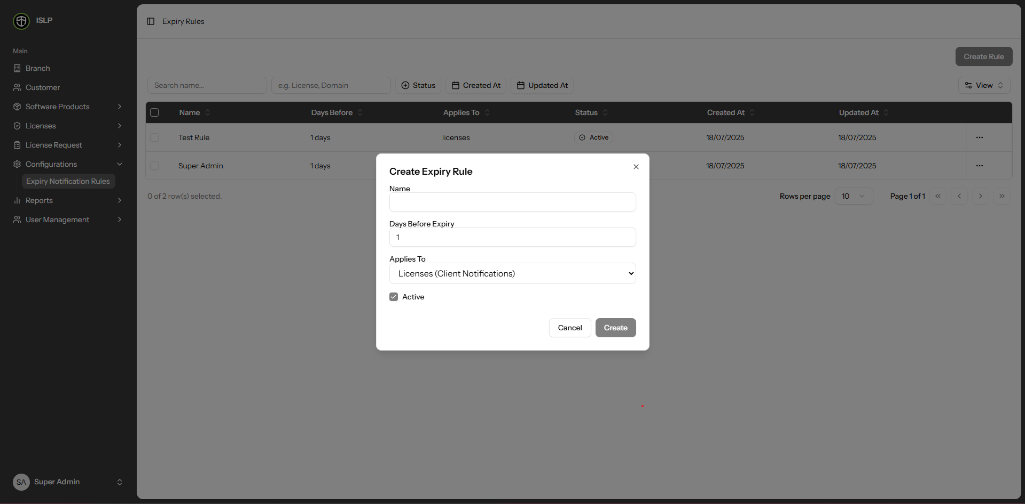

* Name – Input the name.

* Days Before Expiry – Enter the number of days before the license expires.

* Applies To – Select the applies to, choose the applies to from the dropdown.

To update a Rules, click the Edit button. Then, edit in the following fields.

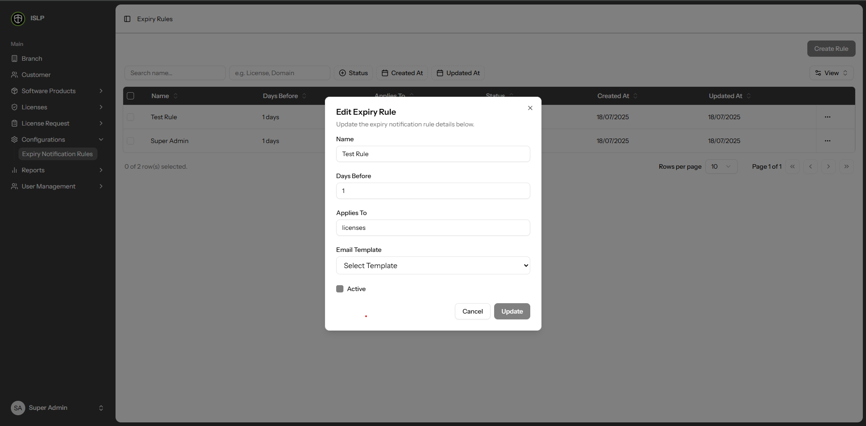

* Name – Input the name.

* Days Before Expiry – Enter the number of days before the license expires.

* Applies To – Select the applies to, choose the applies to from the dropdown.

* Email Template – Select the email template to, choose the email template to from the dropdown.

- Software Product Invoice Modules

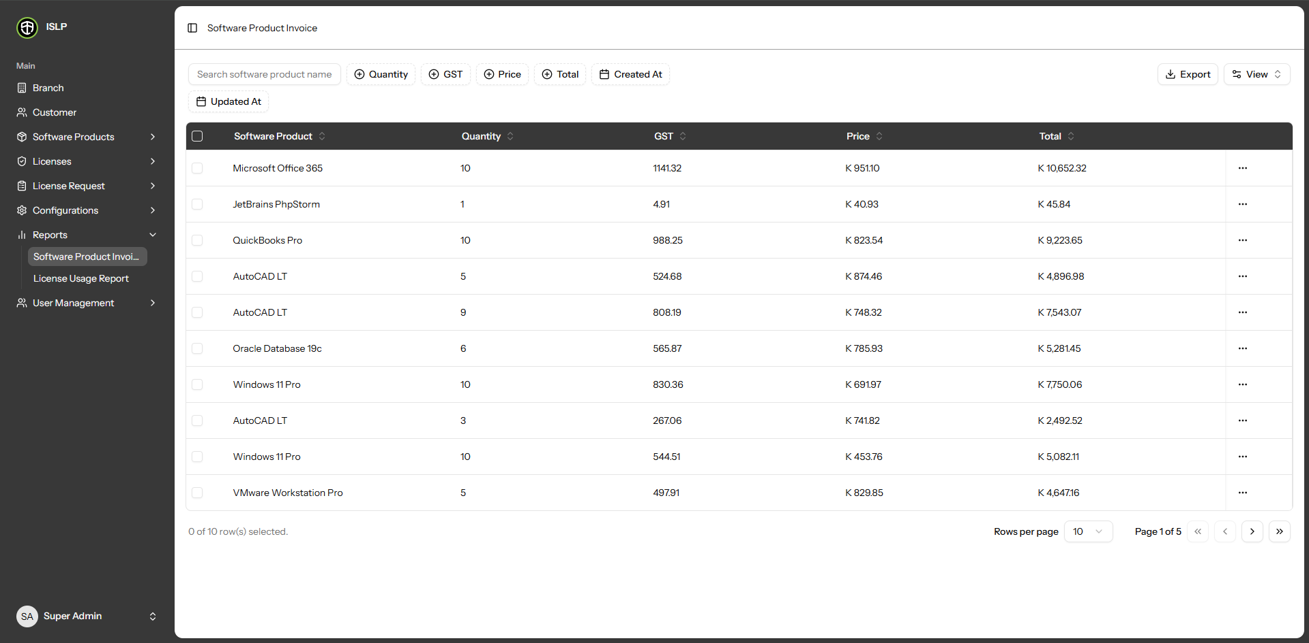

- Software Product Invoice are managed through the Software Product Invoice Table, where you can view and delete

- You can browse the list and detailed view of all existing Software Product Invoice

- Users can delete Software Product Invoice records from the table,

- A search box is available to find Software Product Name by Software Product Name.

- A search box is available to find License by License Domain.

- You can use the 'Quantity Filter' fields to find records based on quantity criteria.

- You can use the 'GST Filter' fields to find records based on gst criteria.

- You can use the 'Price Filter' fields to find records based on price criteria.

- You can use the 'Total Filter' fields to find records based on total criteria.

- You can use the 'Created At' or 'Updated At' fields to find records based on when they were created or last updated.

- If you want to export Software Product Invoice records, simply click the Export button. The exported data will be displayed in tabular format.

- You can use the View button in the filter column on the right side of the table to hide or unhide columns as needed.

- Click the column header if you want to sort in ascending or descending order, or to hide the column.

- The data table includes a pagination filter allowing you to select how many rows to display per page (10, 20, 30, 40, or 50).
- License Usage Report Modules

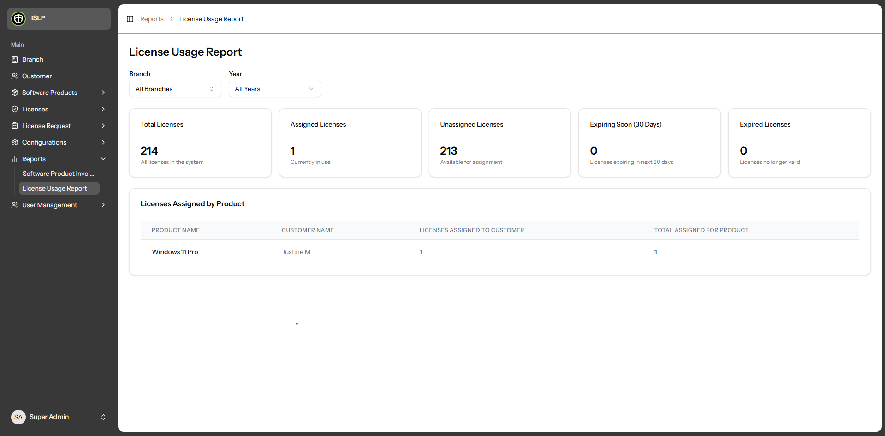

- License Usage Reports are managed through the License Usage Report section, where you can view relevant data.
- You can browse a list view and detailed view of all existing License Usage Reports.
- Use the 'Total Licenses' field to filter records based on total license count criteria.
- Use the 'Assigned Licenses' field to filter records based on assigned license criteria.
- Use the 'Unassigned Licenses' field to filter records based on unassigned license criteria.
- Use the 'Expiring Soon (30 Days)' field to filter records based on licenses expiring within 30 days.
- Use the 'Expired Licenses' field to filter records based on already expired licenses.
- License Assigned by Product data is managed in the corresponding section, where you can view product names, customer names, licenses assigned to customers, and the total assigned per product.

